**201. TRELLO_UPDATE_BOARD_STAR_POSITION**

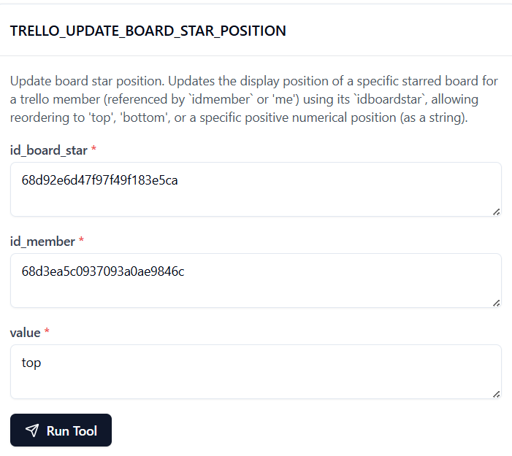

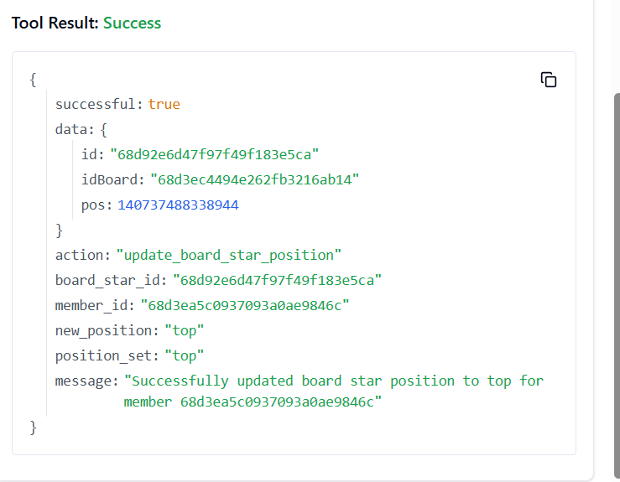

**202. TRELLO_UPDATE_CARD_CHECKLIST_ITEM_POSITION**

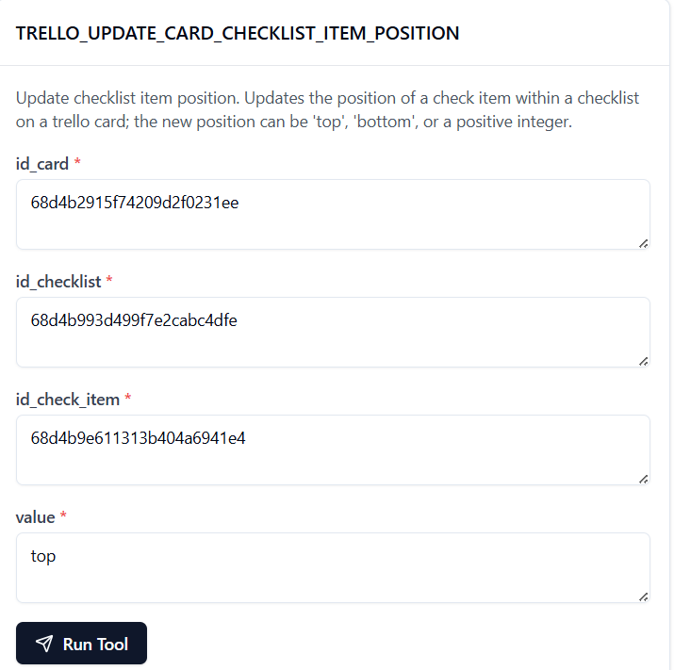

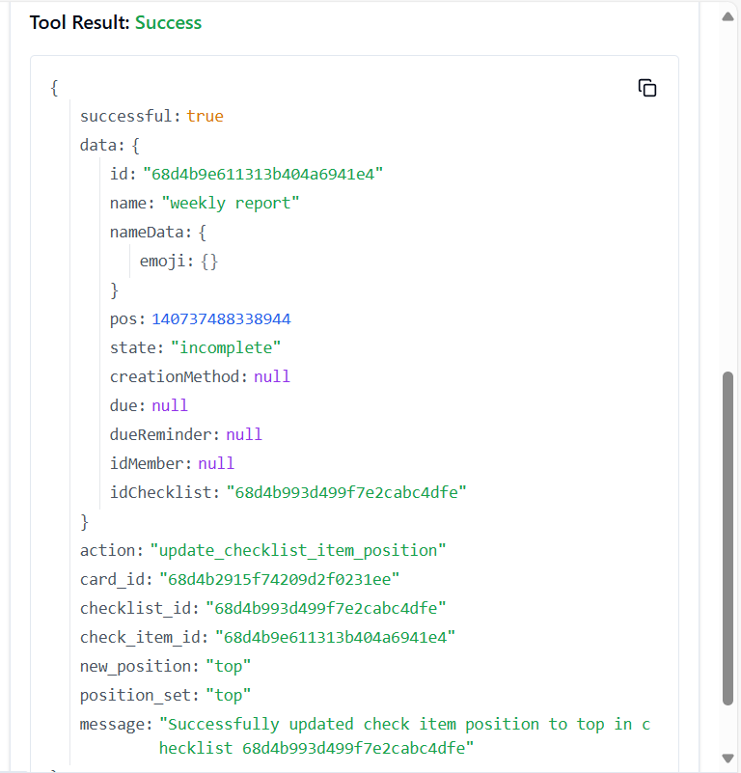

**203. TRELLO_UPDATE_CARD_CHECKLIST_ITEM_STATE_BY_IDS**

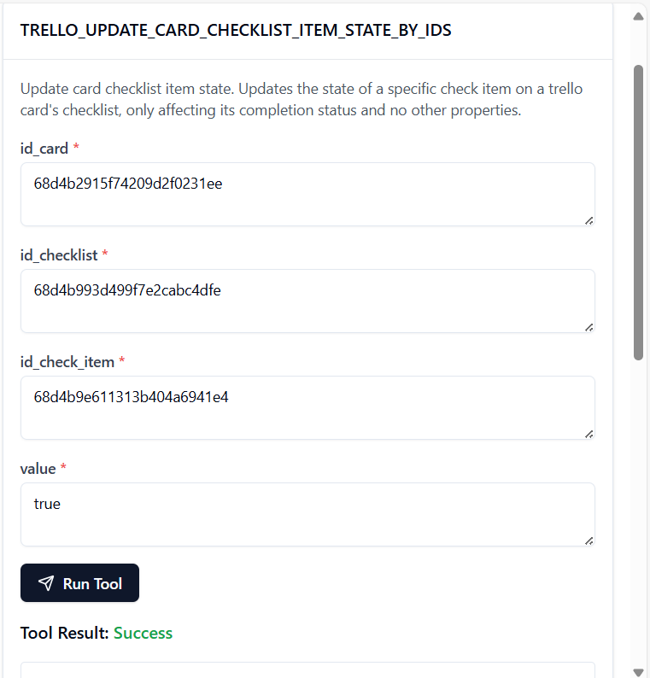

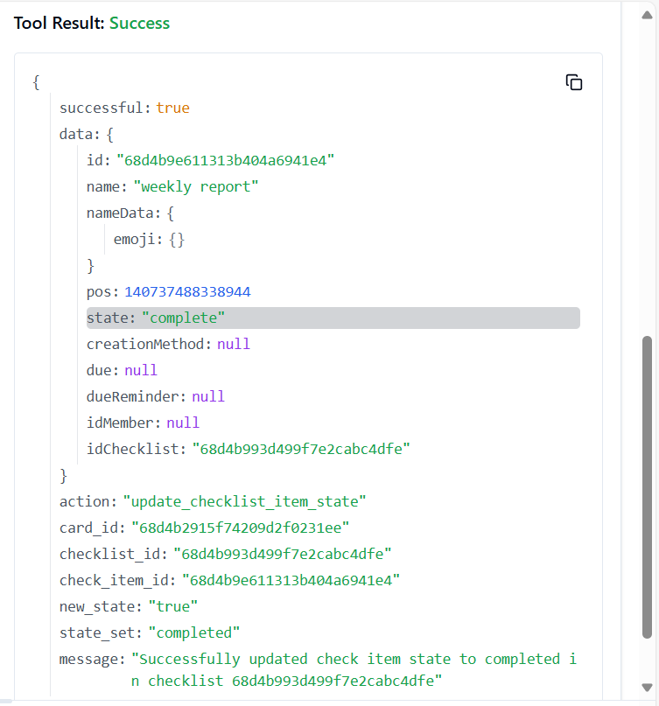

**204. TRELLO_UPDATE_CARD_COMMENT**

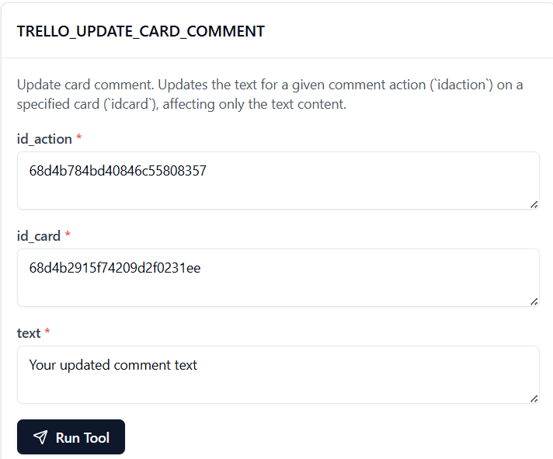

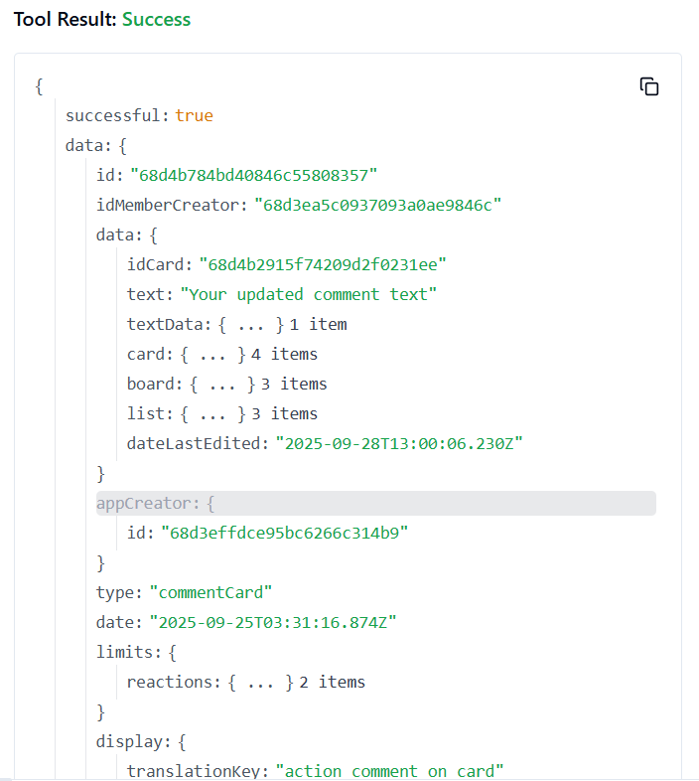

**205. TRELLO_UPDATE_CARDS_CLOSED_BY_ID_CARD**

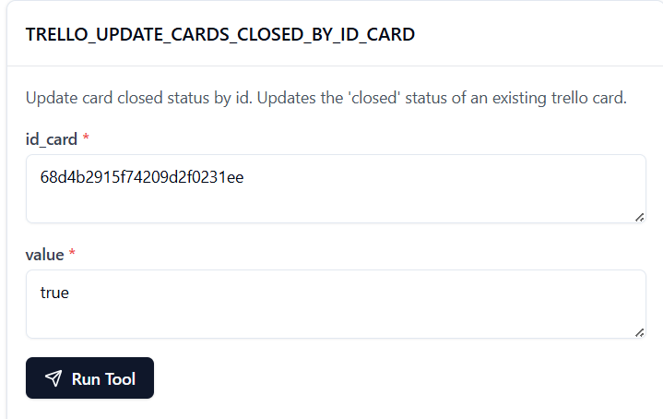

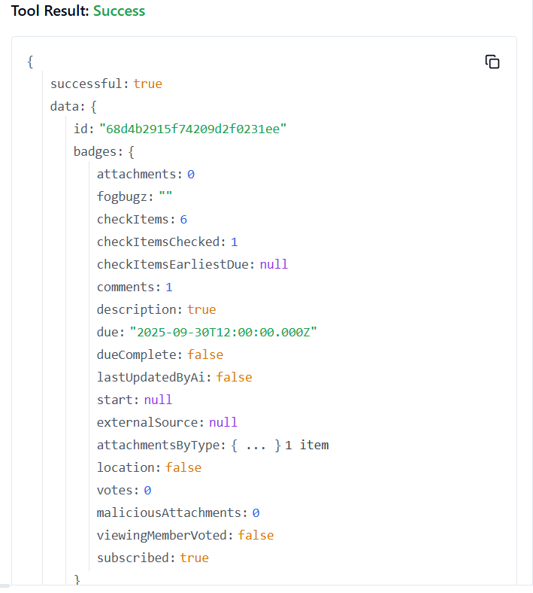

**206. TRELLO_UPDATE_CARDS_DESC_BY_ID_CARD**

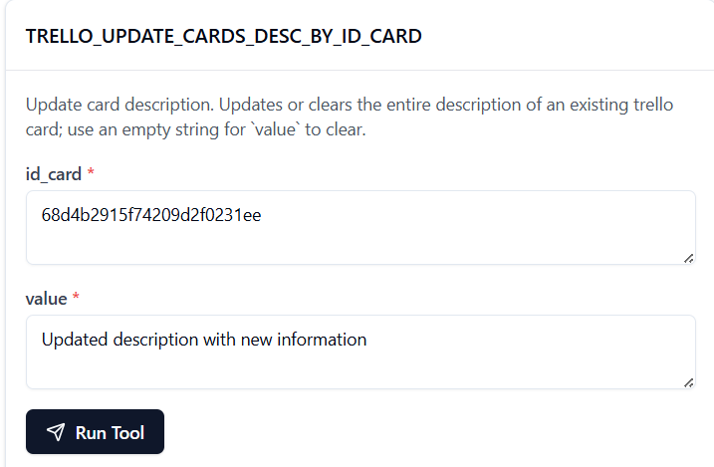

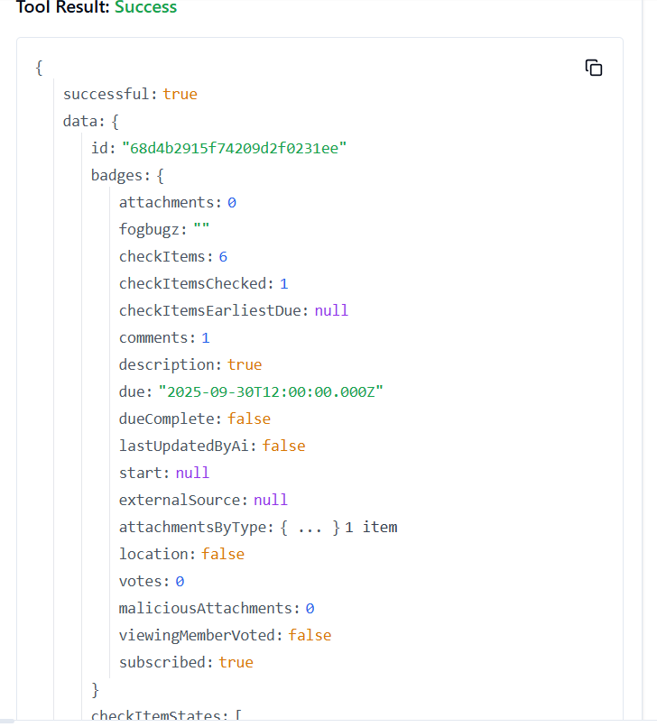

**207. TRELLO_UPDATE_CARDS_DUE_BY_ID_CARD**

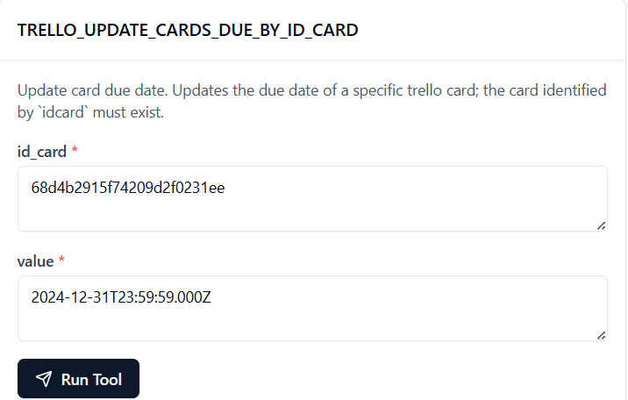

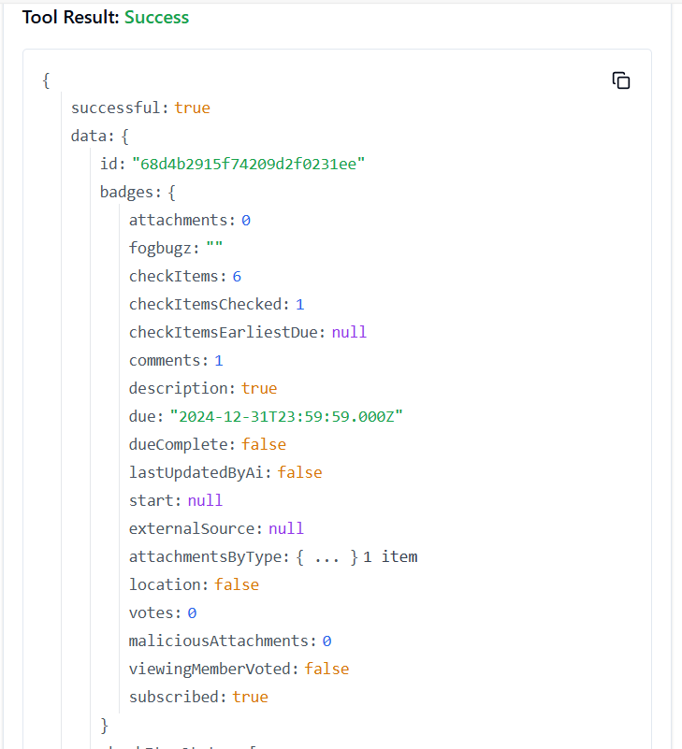

**208. TRELLO_UPDATE_CARDS_ID_BOARD_BY_ID_CARD**

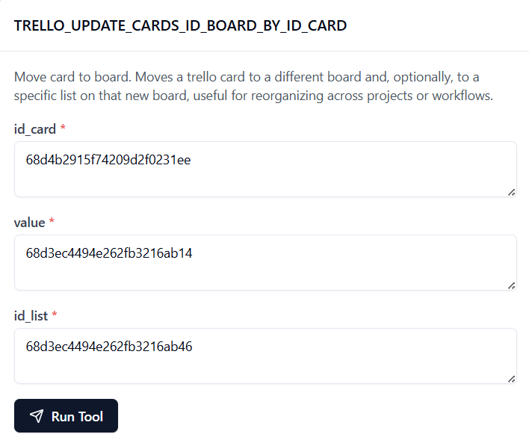

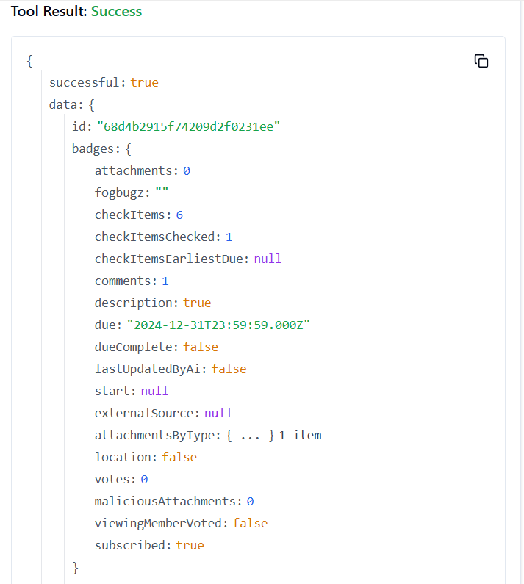

**209. TRELLO_UPDATE_CARDS_ID_LIST_BY_ID_CARD**

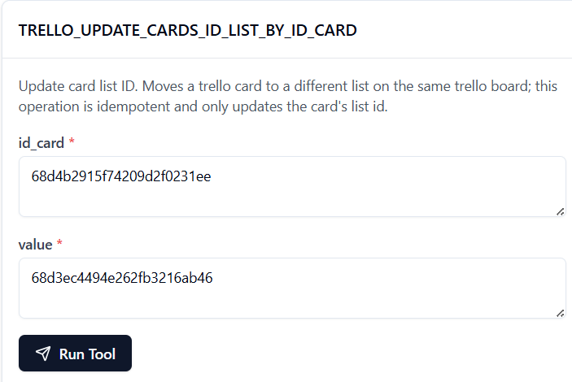

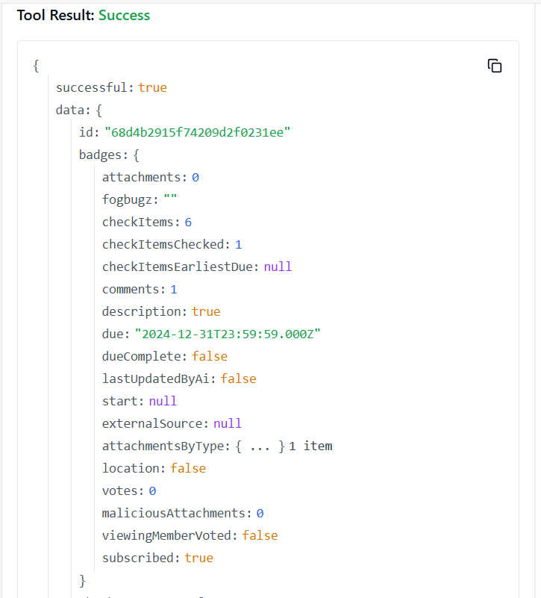

**210. TRELLO_UPDATE_CARDS_ID_MEMBERS_BY_ID_CARD**

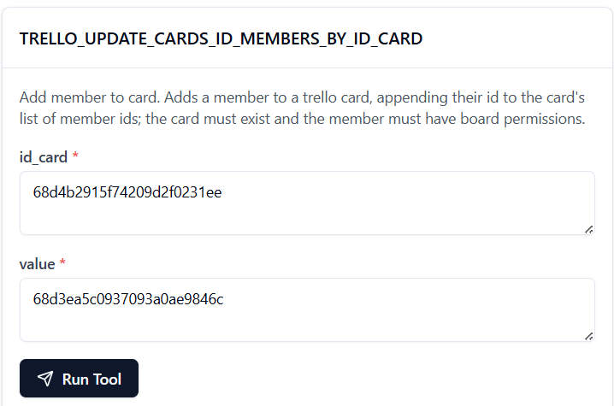

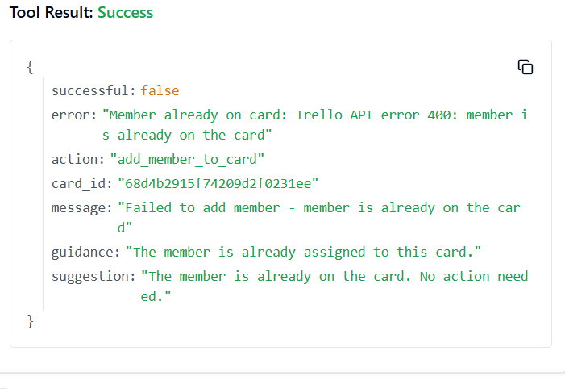

**211. TRELLO_UPDATE_CARDS_LABELS_BY_ID_CARD**

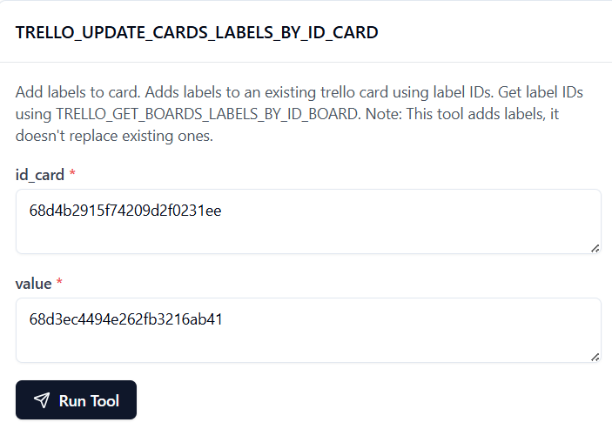

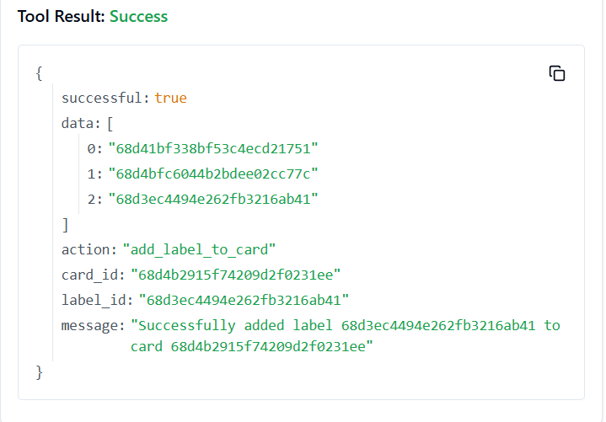

**212. TRELLO_UPDATE_CARDS_NAME_BY_ID_CARD**

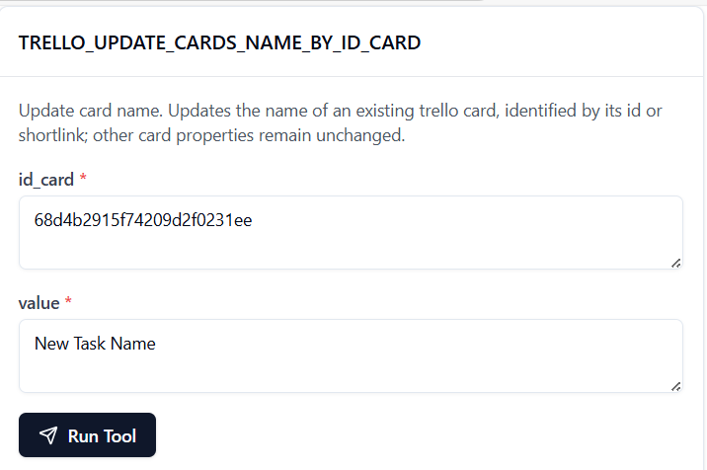

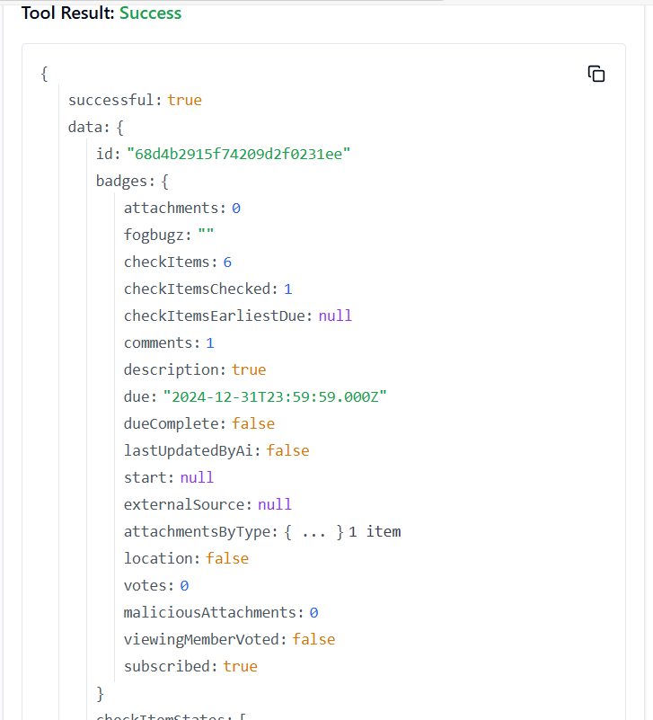

**213. TRELLO_UPDATE_CARDS_POS_BY_ID_CARD**

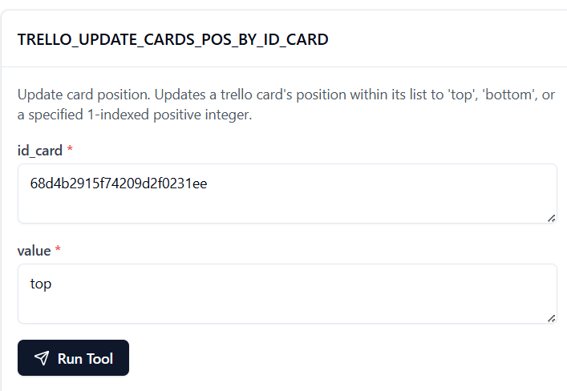

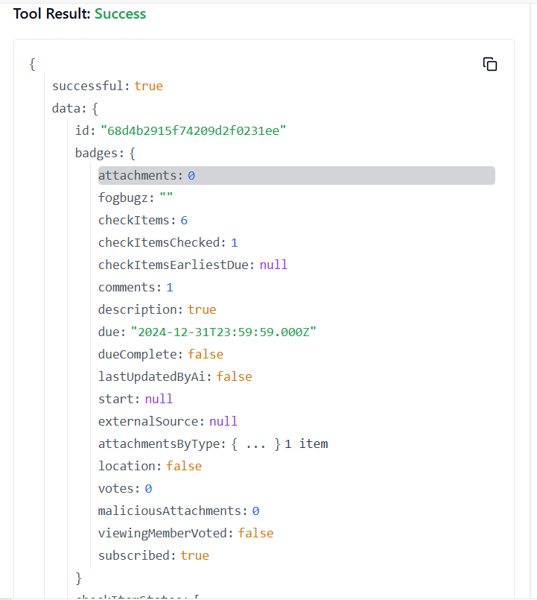

**214. TRELLO_UPDATE_CARDS_SUBSCRIBED_BY_ID_CARD**

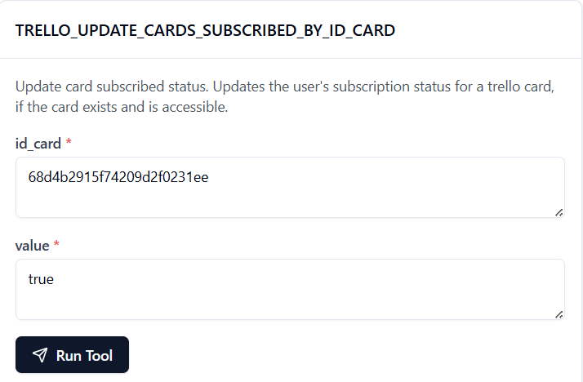

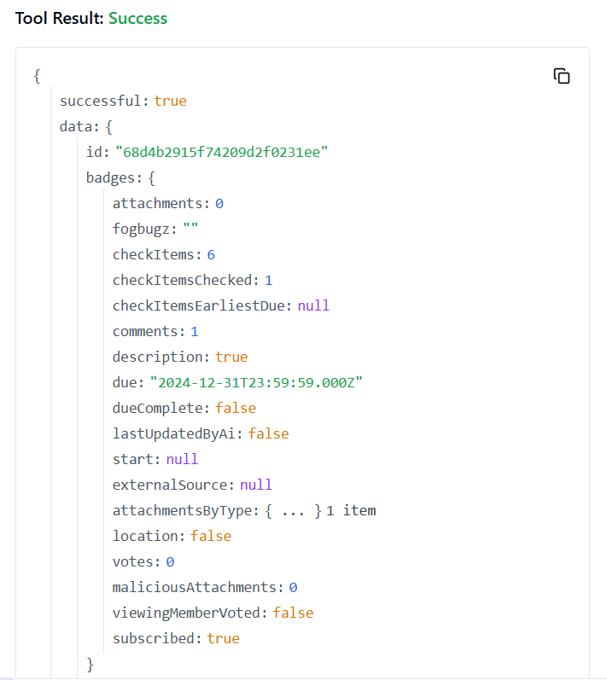

**215. TRELLO_UPDATE_CHECKLIST_ITEM_BY_IDS**

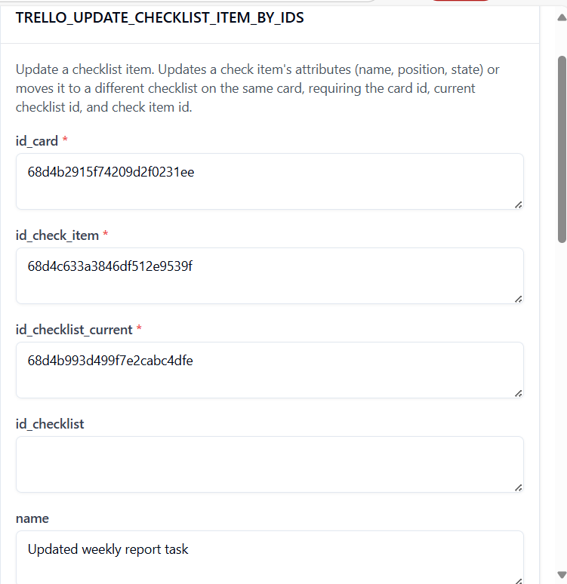

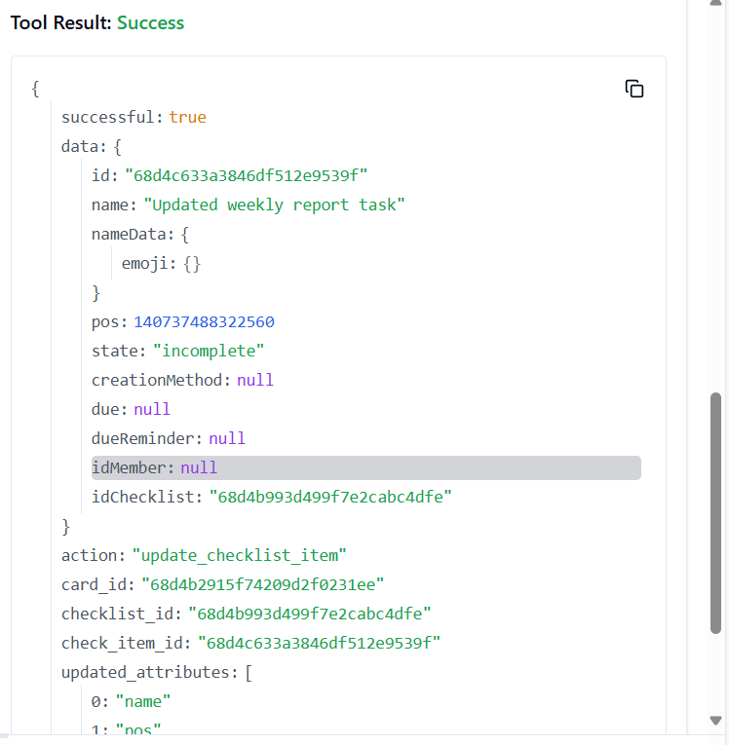

**216. TRELLO_UPDATE_CHECKLIST_ITEM_NAME_IN_CARD**

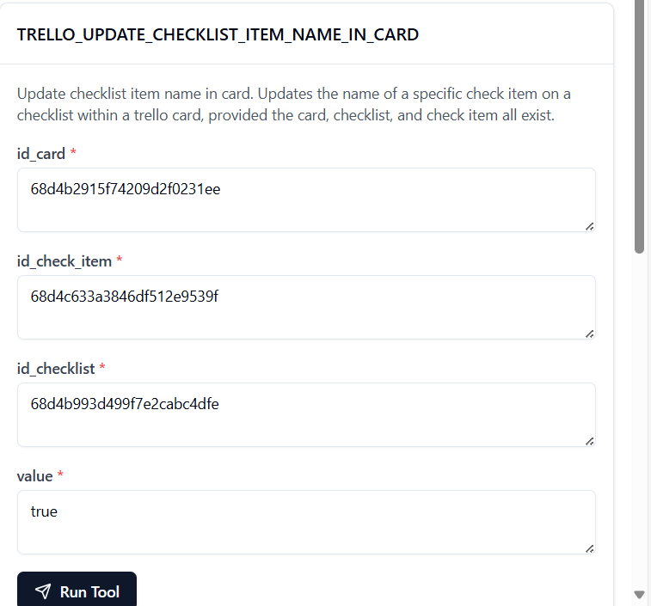

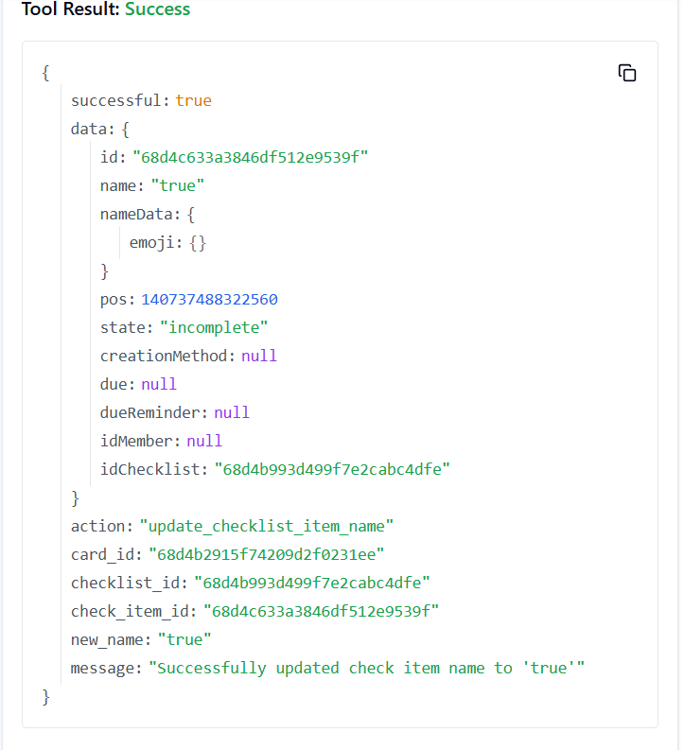

**217. TRELLO_UPDATE_CHECKLISTS_BY_ID_CHECKLIST**

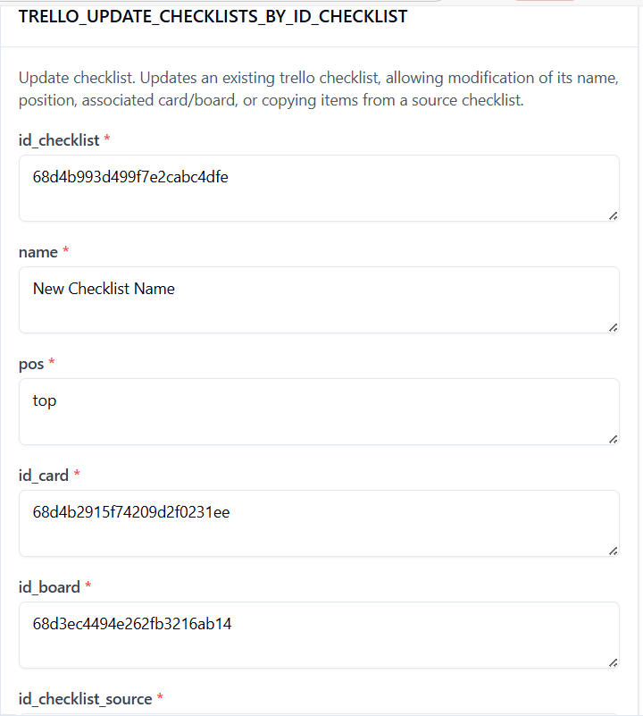

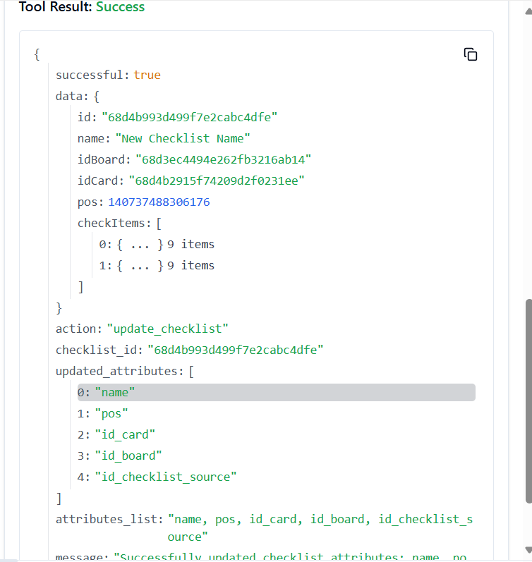

**218. TRELLO_UPDATE_CHECKLISTS_ID_CARD_BY_ID_CHECKLIST**

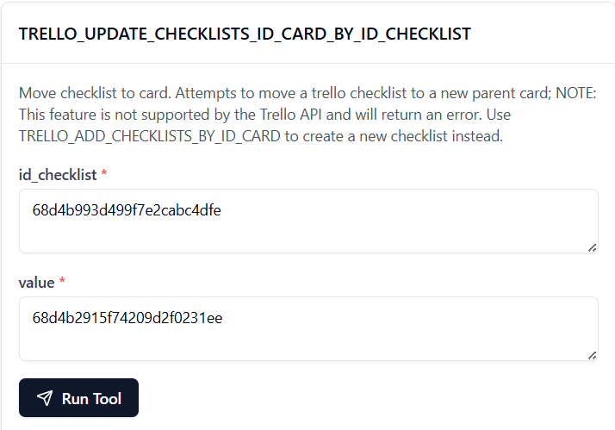

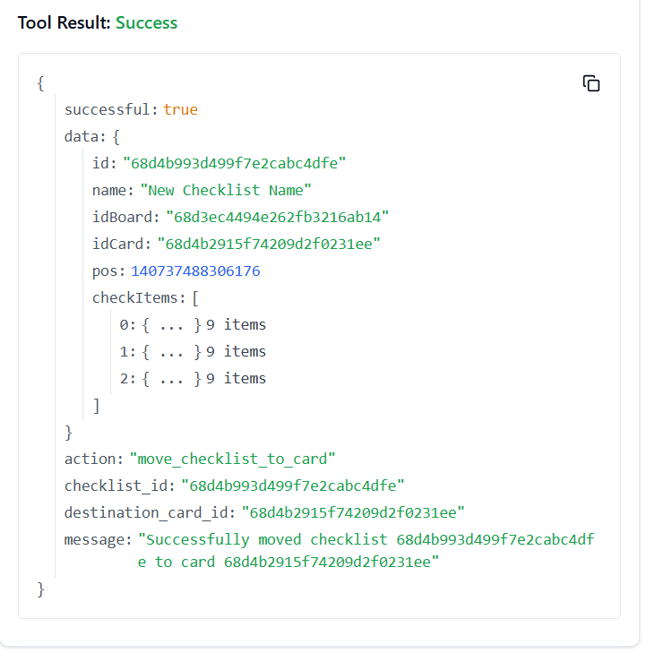

**219. TRELLO_UPDATE_CHECKLISTS_NAME_BY_ID_CHECKLIST**

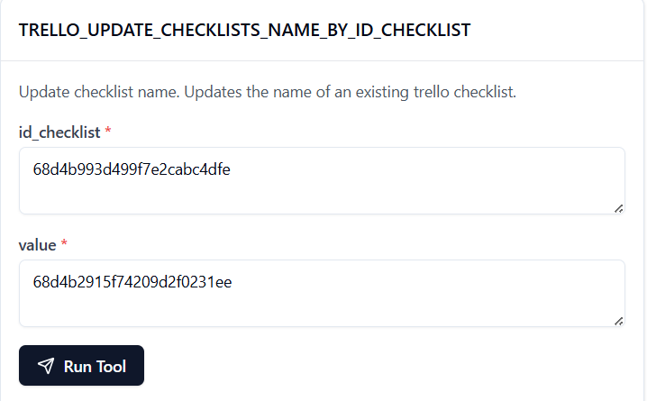

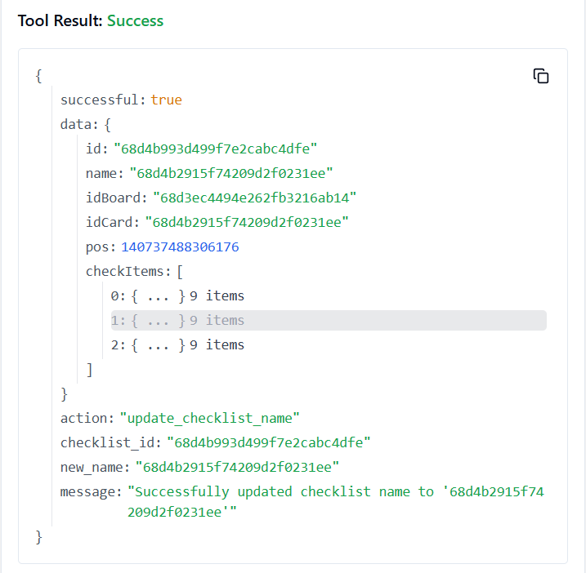

**220. TRELLO_UPDATE_CHECKLISTS_POS_BY_ID_CHECKLIST**

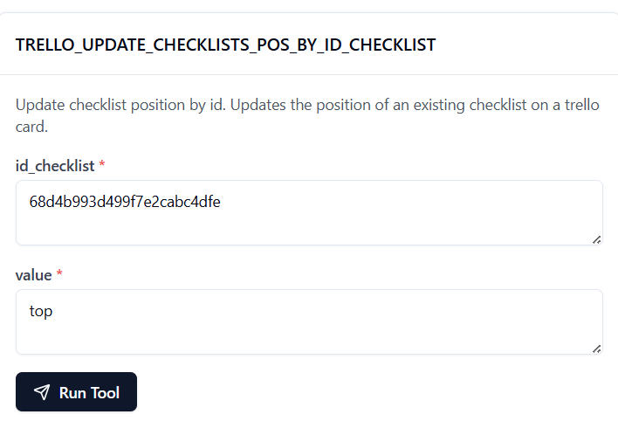

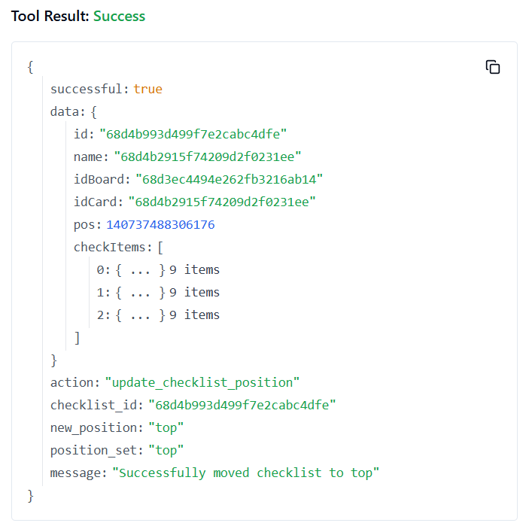

**221. TRELLO_UPDATE_LABELS_BY_ID_LABEL**

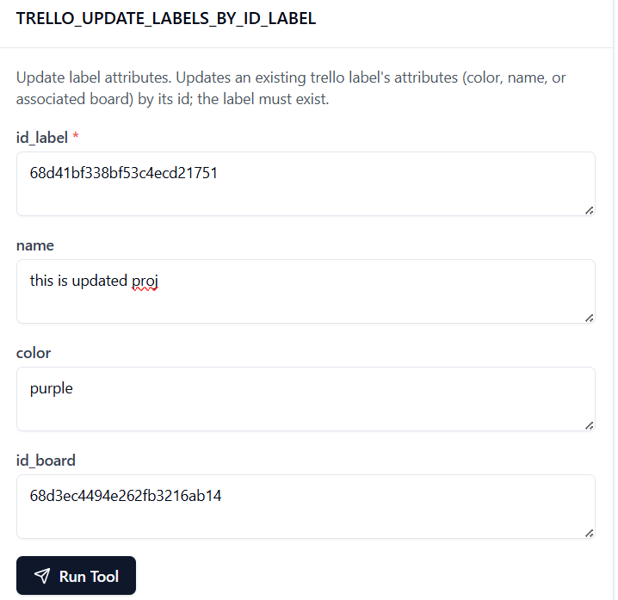

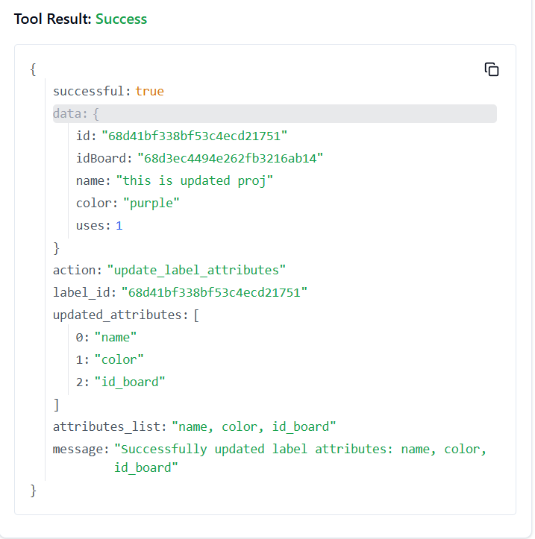

**222. TRELLO_UPDATE_LABELS_COLOR_BY_ID_LABEL**

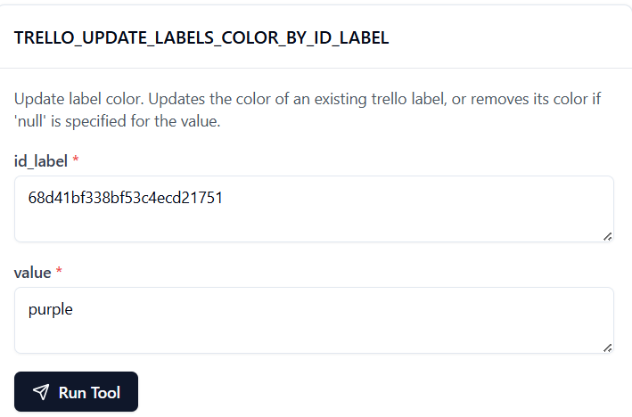

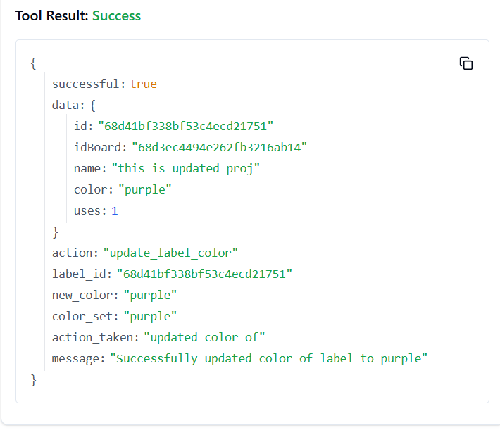

**223. TRELLO_UPDATE_LABELS_NAME_BY_ID_LABEL**

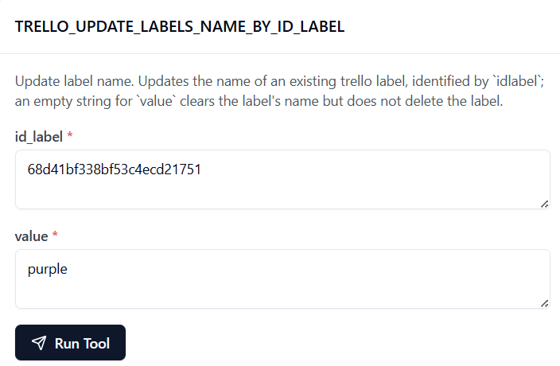

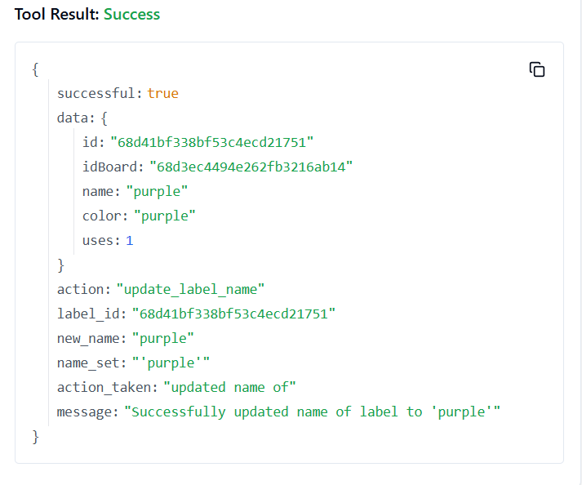

**224. TRELLO_UPDATE_LISTS_BY_ID_LIST**

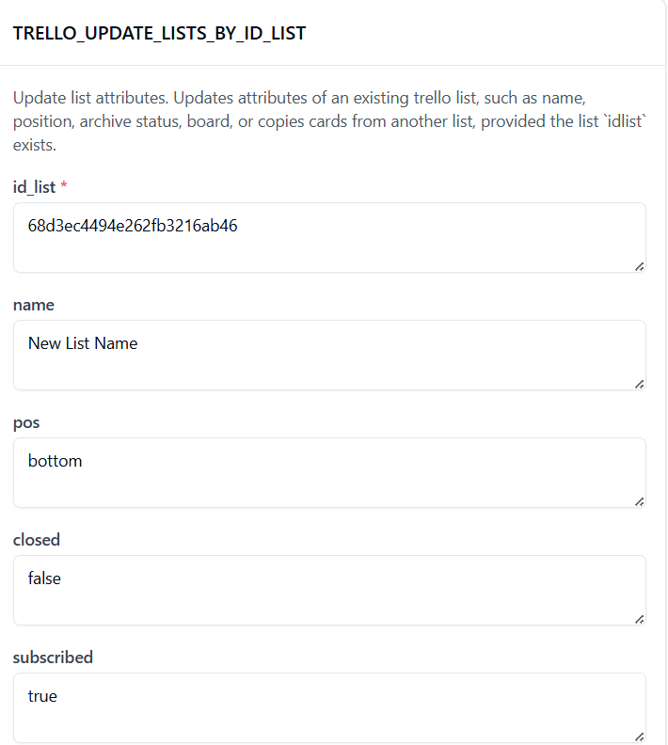

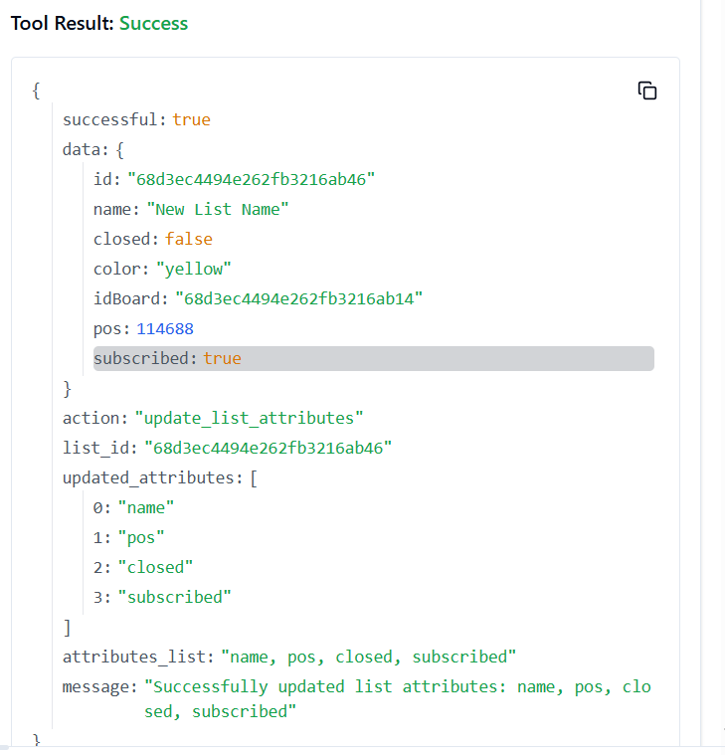

**225. TRELLO_UPDATE_LISTS_CLOSED_BY_ID_LIST**

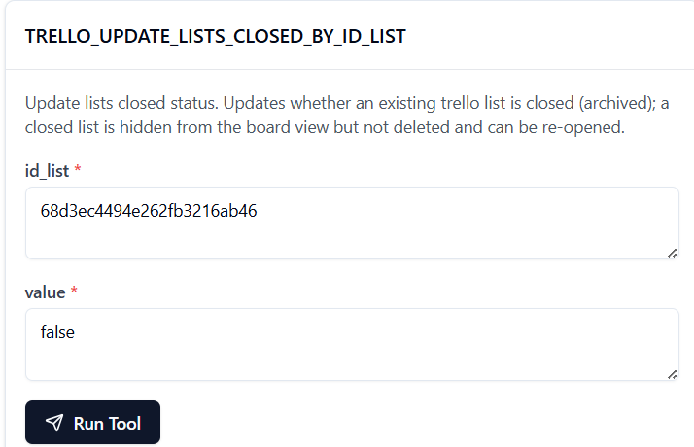

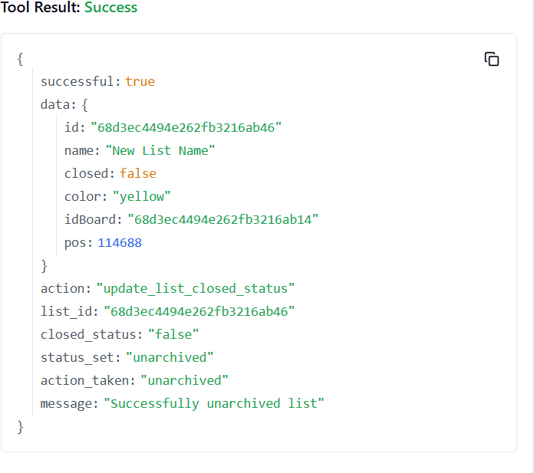

**226. TRELLO_UPDATE_LISTS_ID_BOARD_BY_ID_LIST**

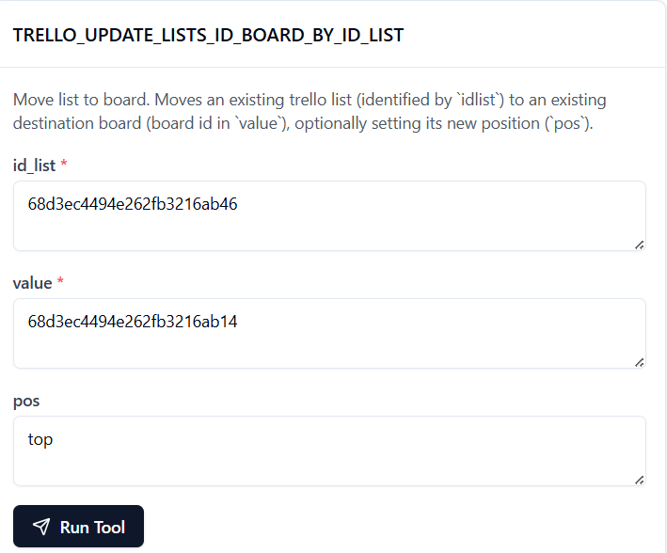

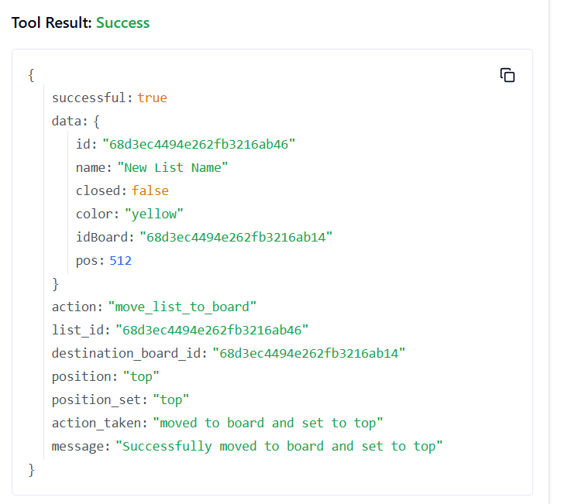

**227. TRELLO_UPDATE_LISTS_NAME_BY_ID_LIST**

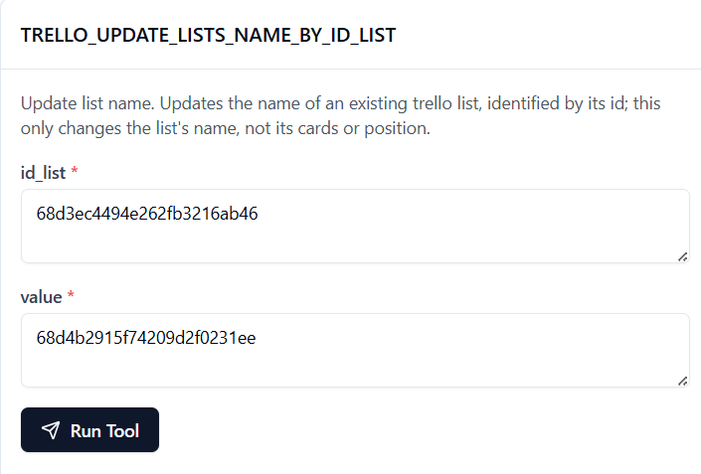

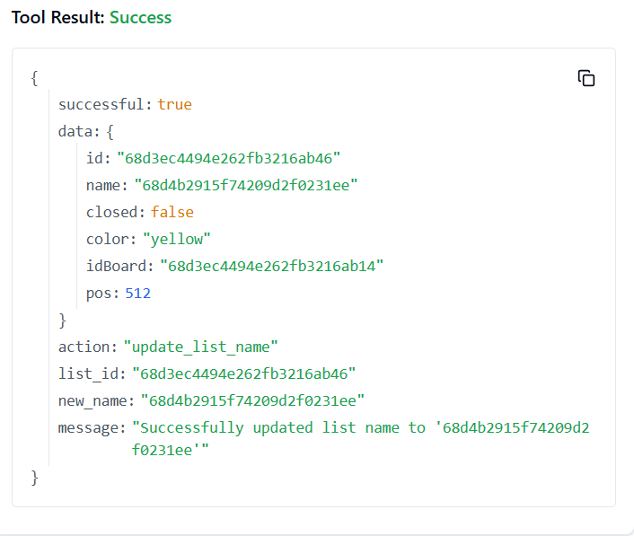

**228. TRELLO_UPDATE_LISTS_POS_BY_ID_LIST**

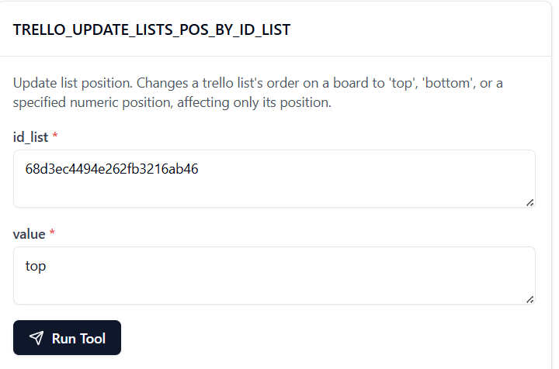

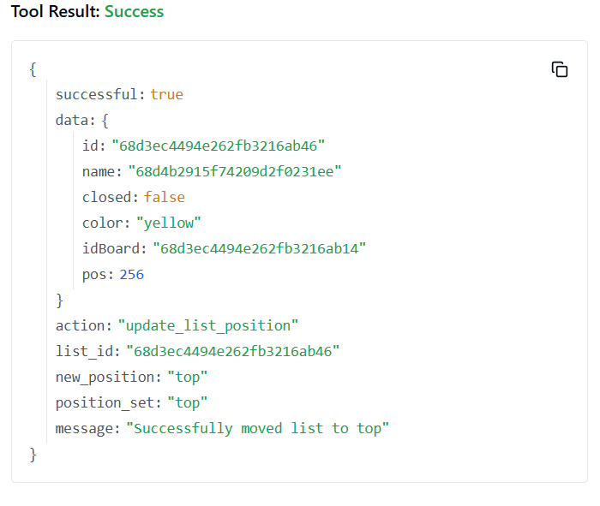

**229. TRELLO_UPDATE_LISTS_SUBSCRIBED_BY_ID_LIST**

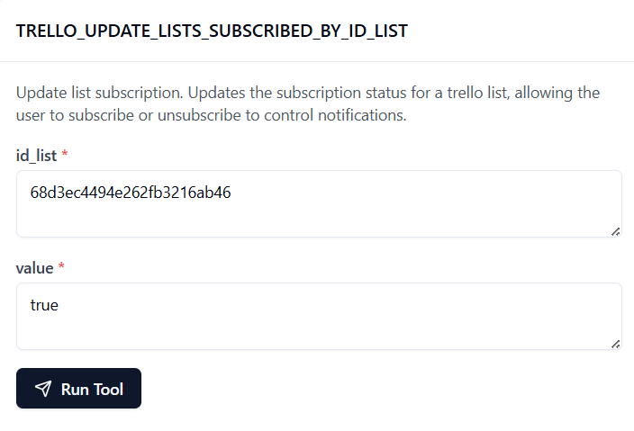

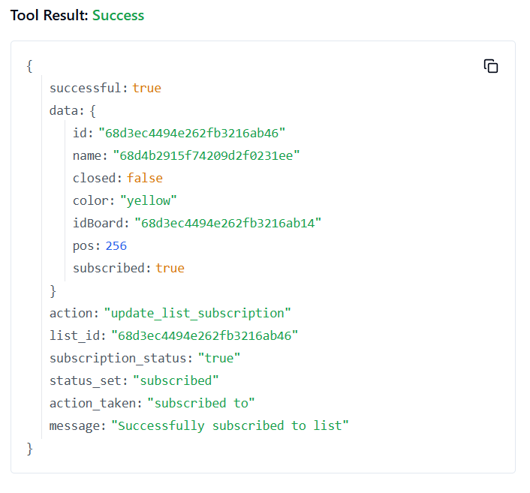

**230. TRELLO_UPDATE_MEMBER_BOARD_BACKGROUND**

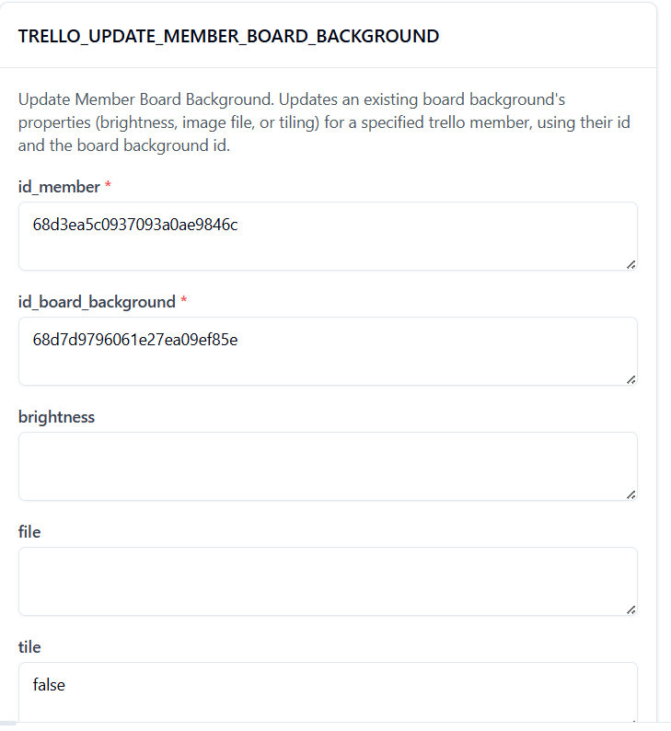

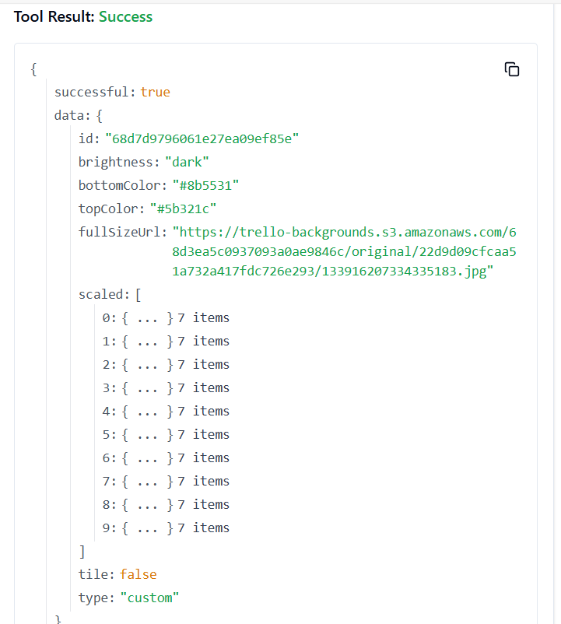

**231. TRELLO_UPDATE_MEMBER_SAVED_SEARCH**

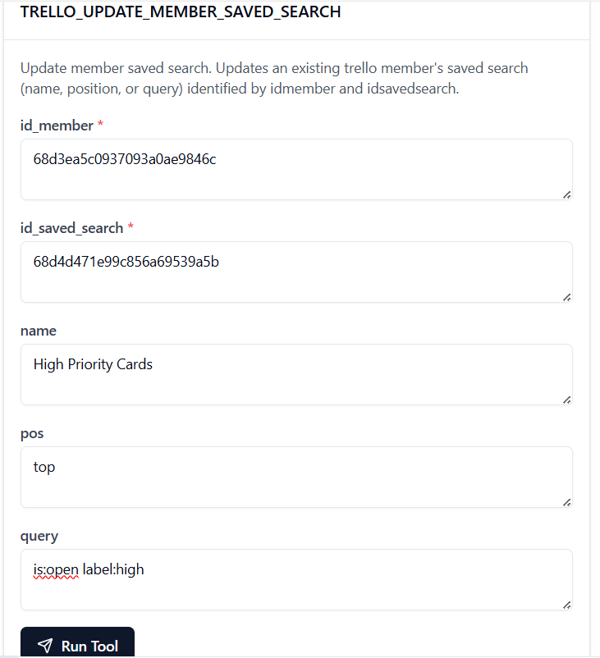

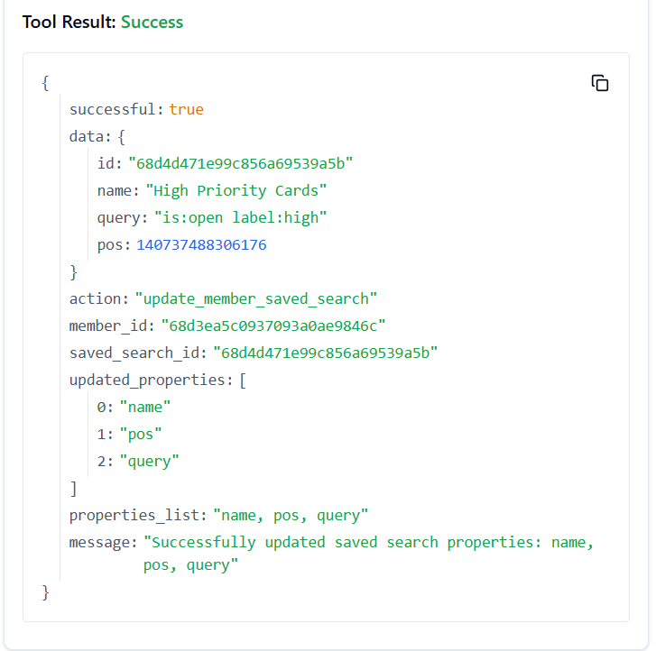

**232. TRELLO_UPDATE_MEMBER_SAVED_SEARCH_NAME**

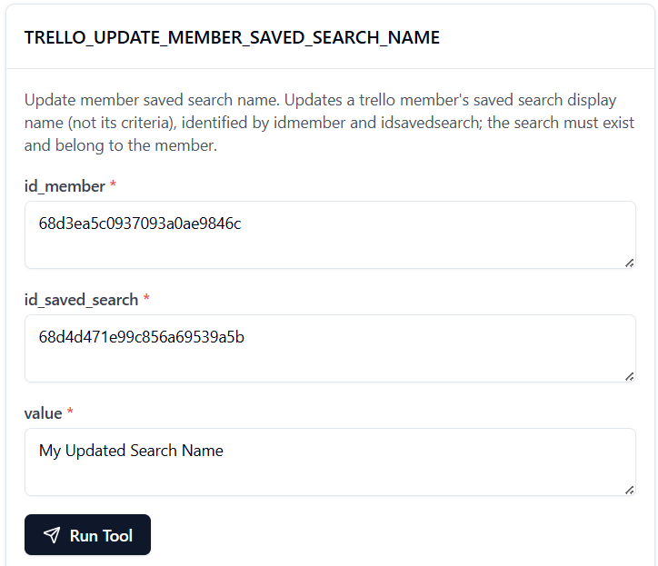

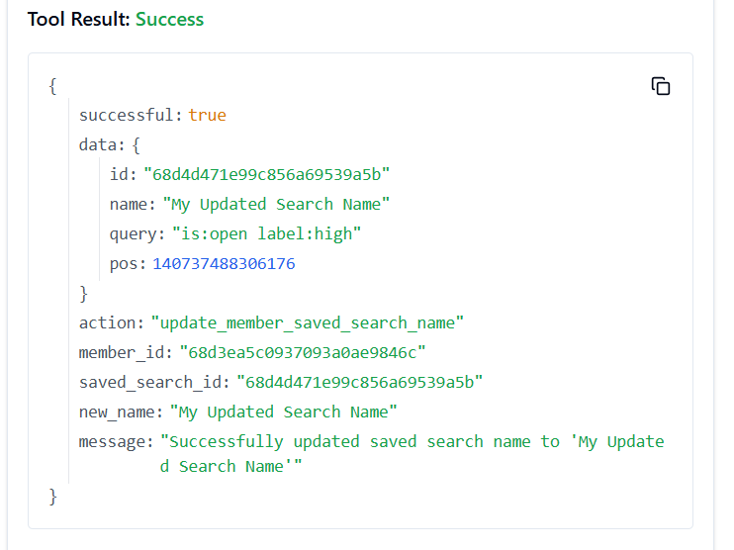

**233. TRELLO_UPDATE_MEMBER_SAVED_SEARCH_POS**

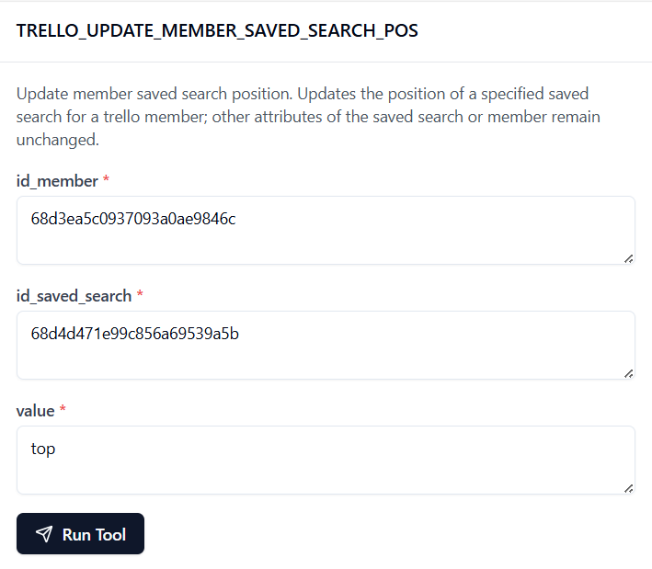

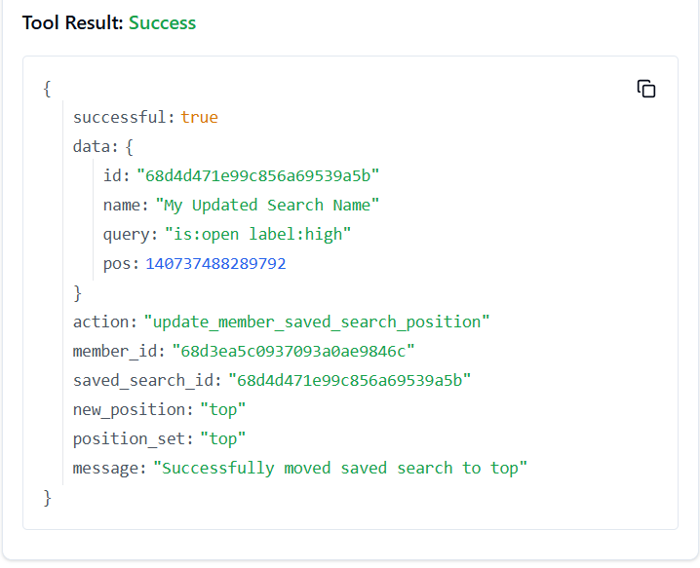

**234. TRELLO_UPDATE_MEMBER_SAVED_SEARCH_QUERY**

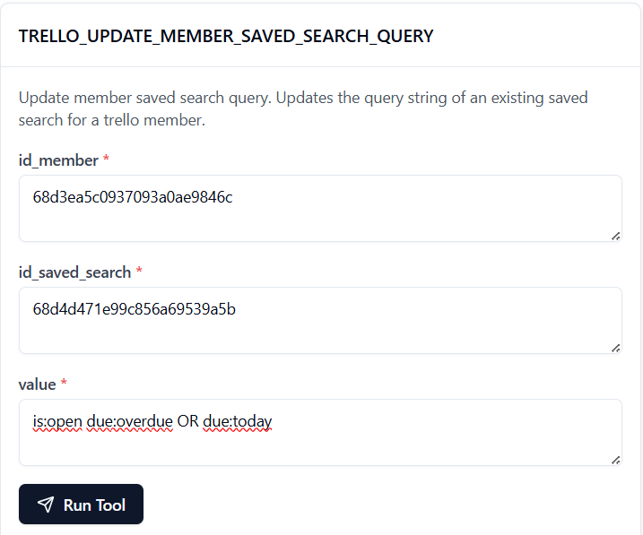

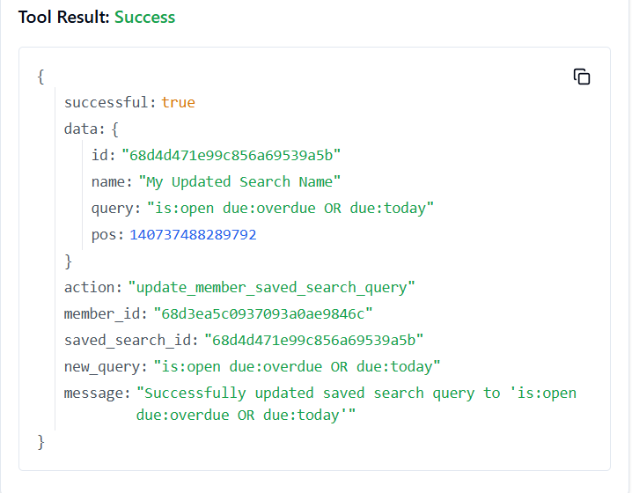

**235. TRELLO_UPDATE_MEMBERS_BIO_BY_ID_MEMBER**

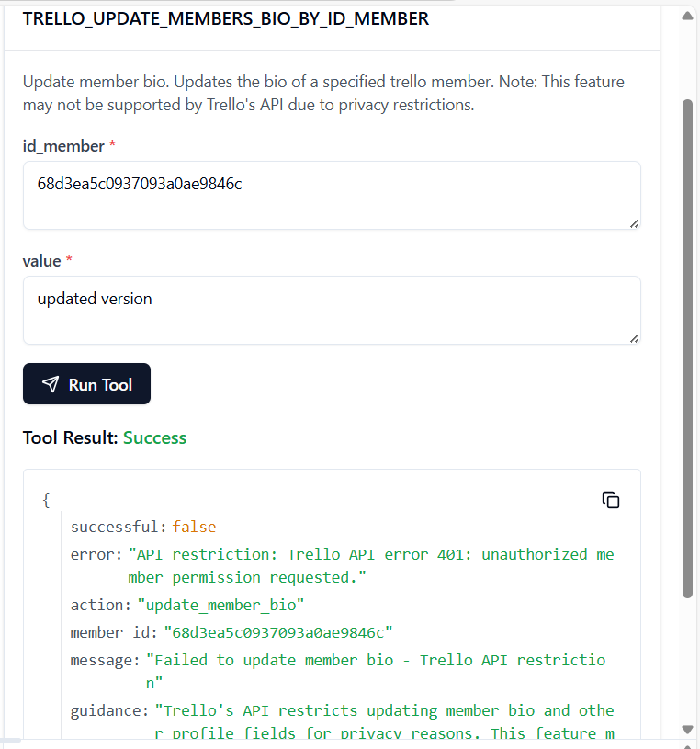

**Tool is running properly but it shows api restrictions**

**236. TRELLO_UPDATE_MEMBER_S_CUSTOM_BOARD_BACKGROUNDS**

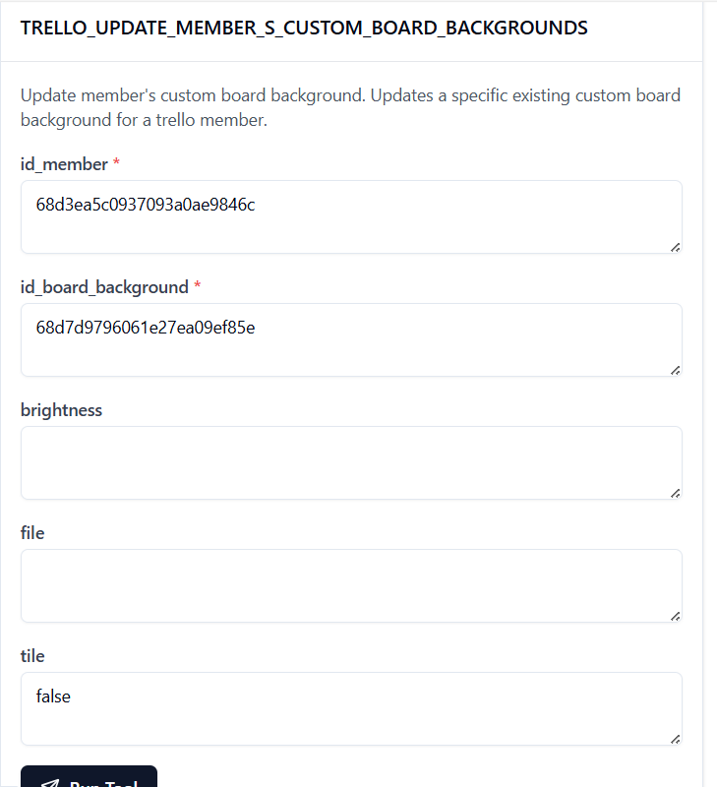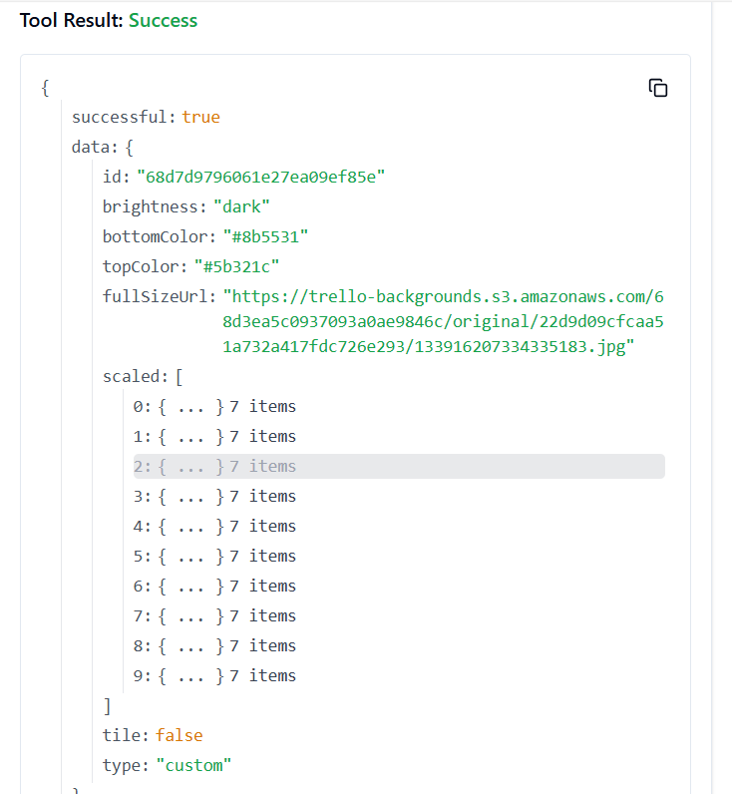

**237. TRELLO_UPDATE_NOTIFICATIONS_BY_ID_NOTIFICATION**

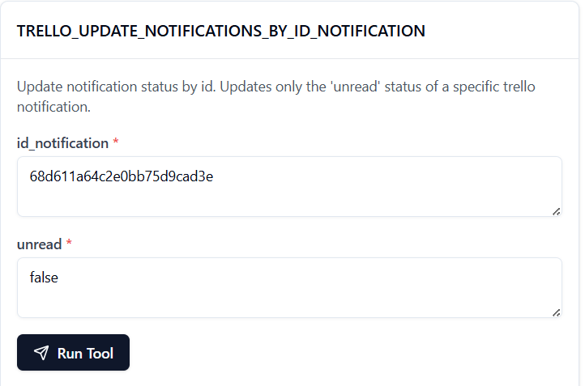

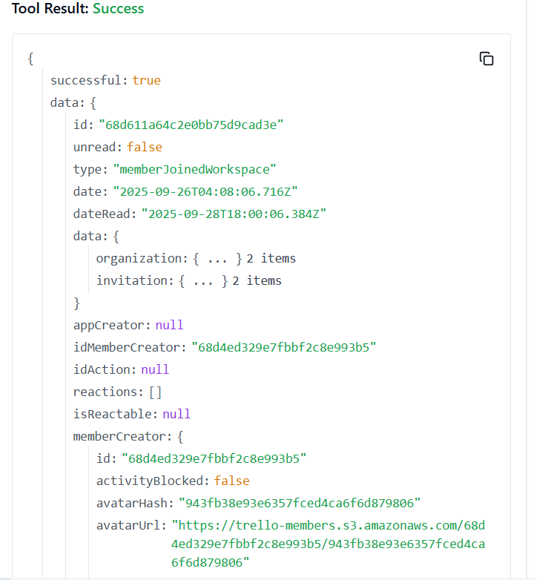

**238. TRELLO_UPDATE_NOTIFICATION_UNREAD_STATUS**

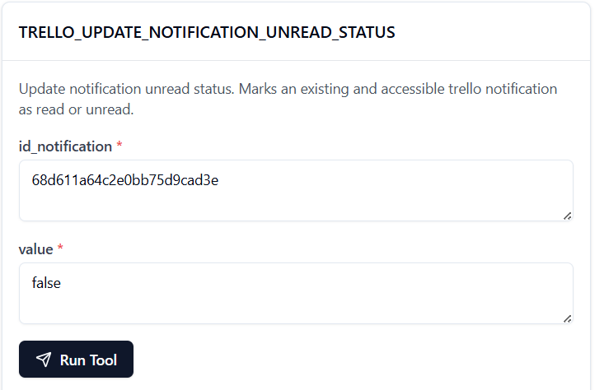

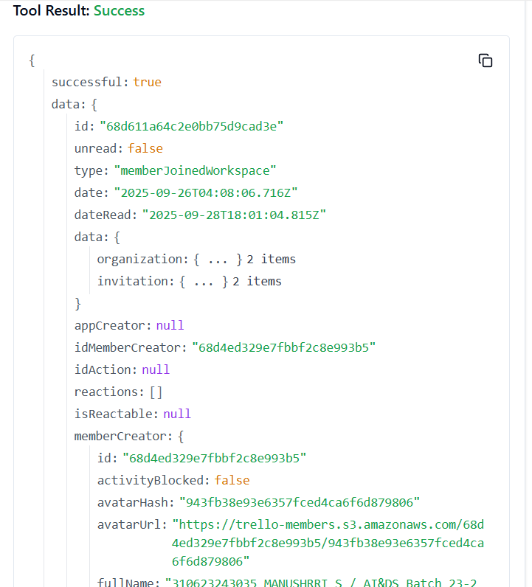

**239. TRELLO_UPDATE_ORGANIZATIONS_BY_ID_ORG**

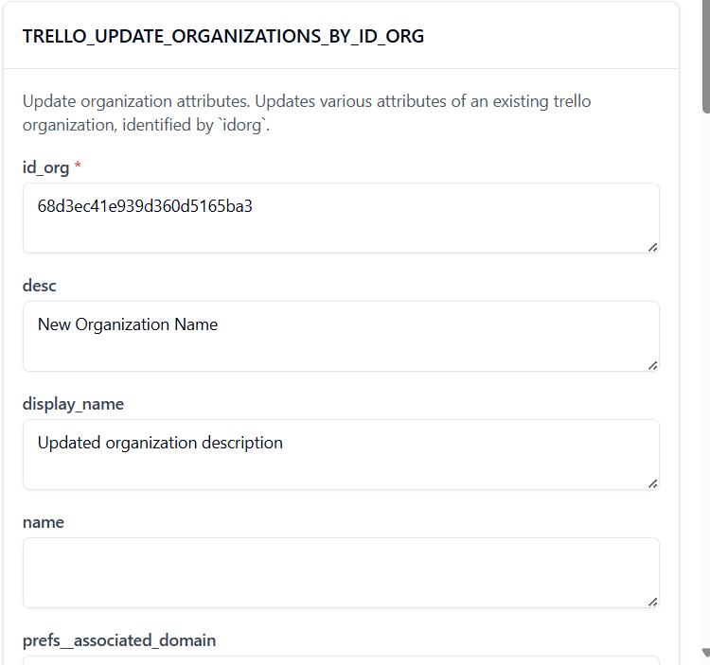

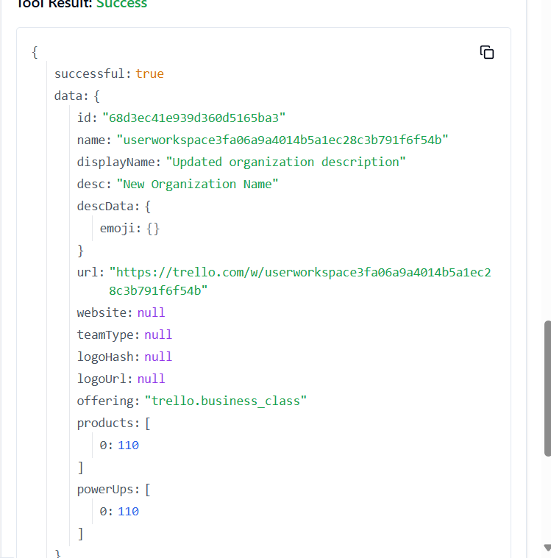

**240. TRELLO_UPDATE_ORGANIZATIONS_DESC_BY_ID_ORG**

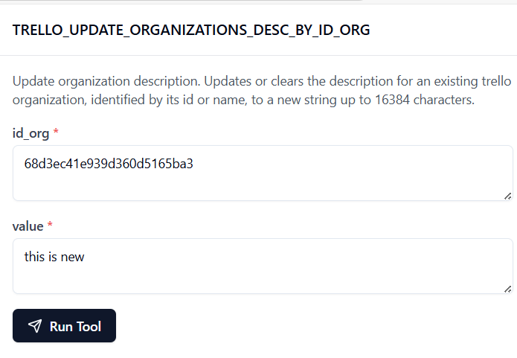

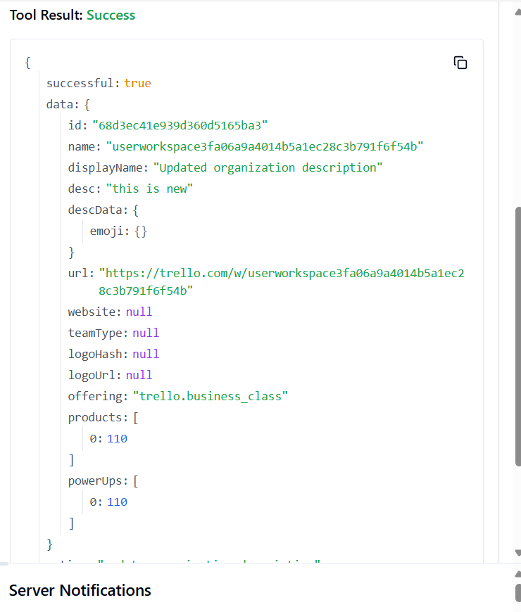

**241. TRELLO_UPDATE_ORGANIZATIONS_DISPLAY_NAME_BY_ID_ORG**

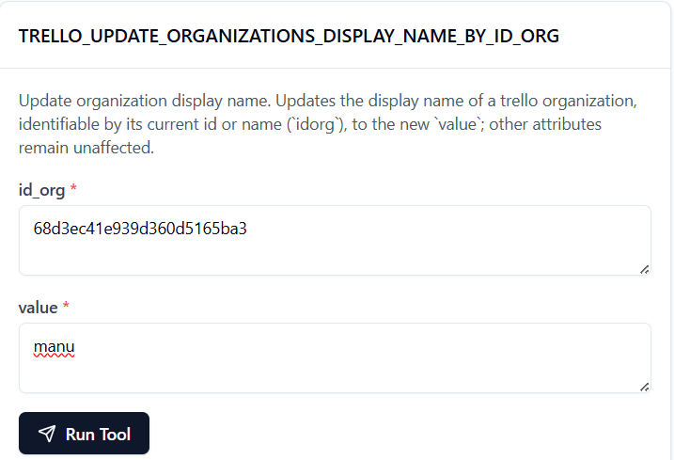

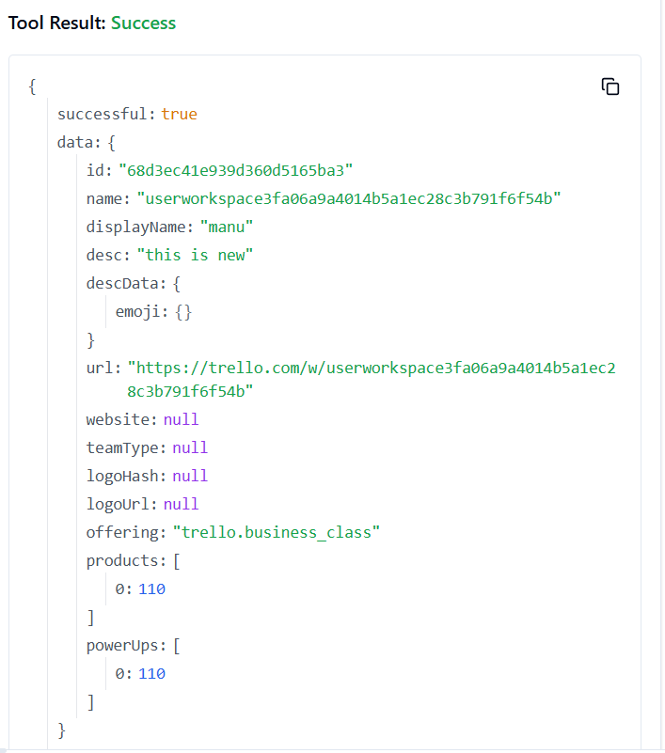

**242. TRELLO_UPDATE_ORGANIZATIONS_PREFS_GOOGLE_APPS_VERSION_BY_ID_ORG**

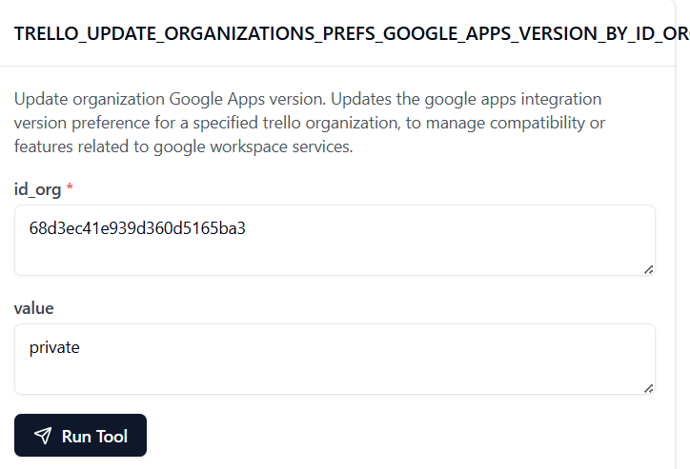

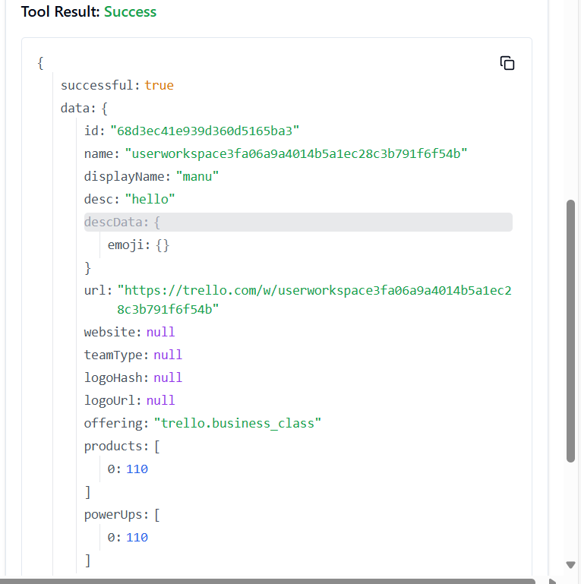

**243. TRELLO_UPDATE_ORGANIZATIONS_PREFS_PERMISSION_LEVEL_BY_ID_ORG**

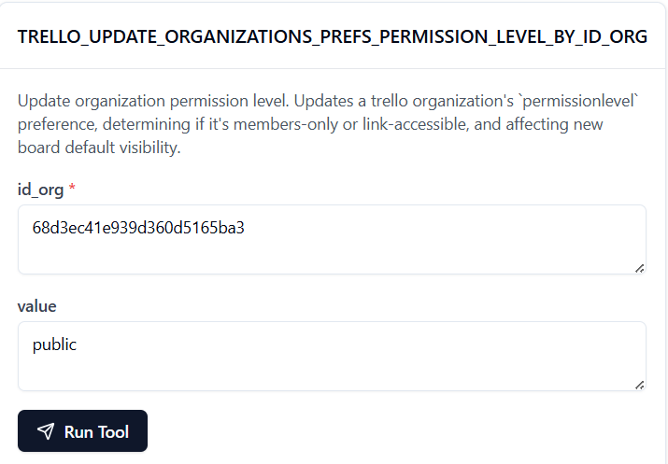

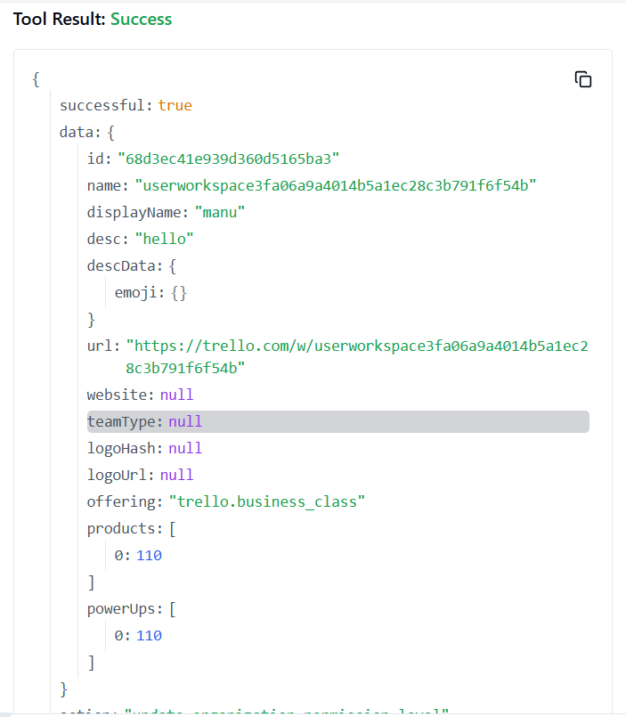

**244. TRELLO_UPDATE_ORG_ASSOCIATED_DOMAIN_PREFS**

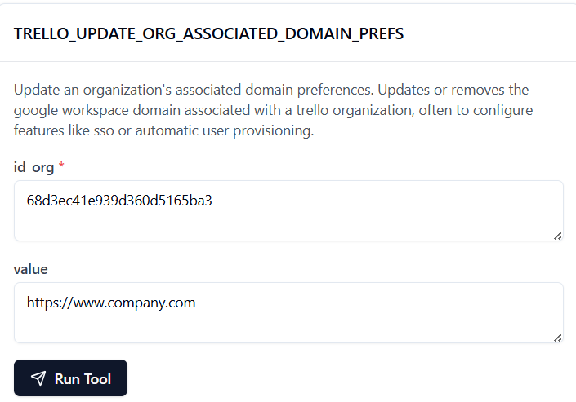

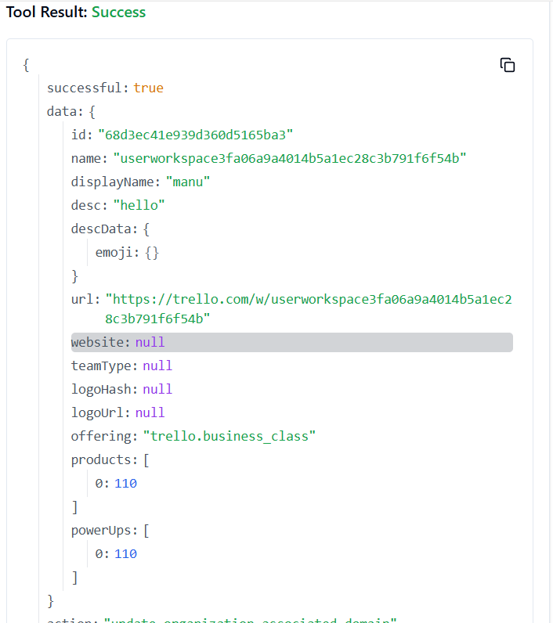

**245. TRELLO_UPDATE_ORGANIZATIONS_WEBSITE_BY_ID_ORG**

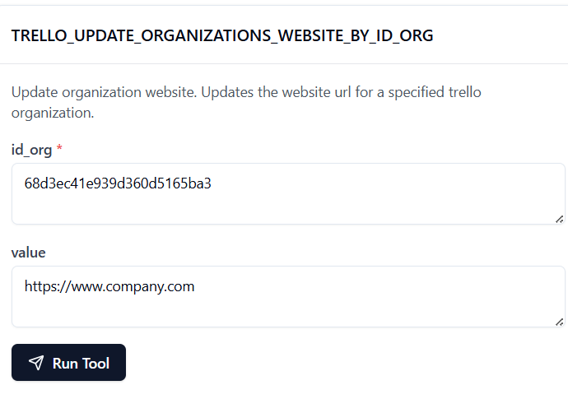

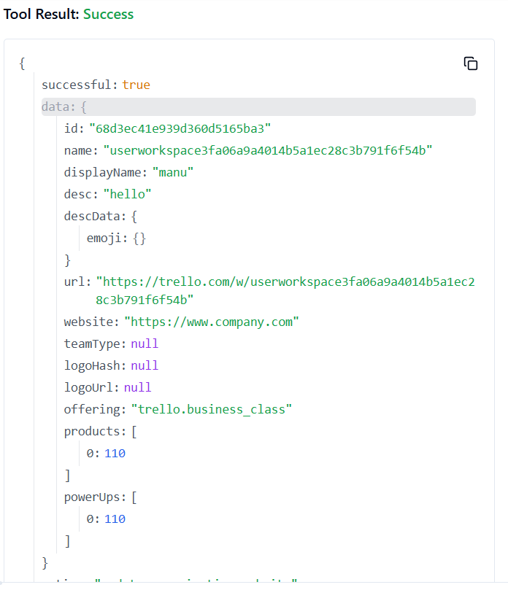

**246. TRELLO_UPDATE_ORG_EXTERNAL_MEMBERS_ACCESS**

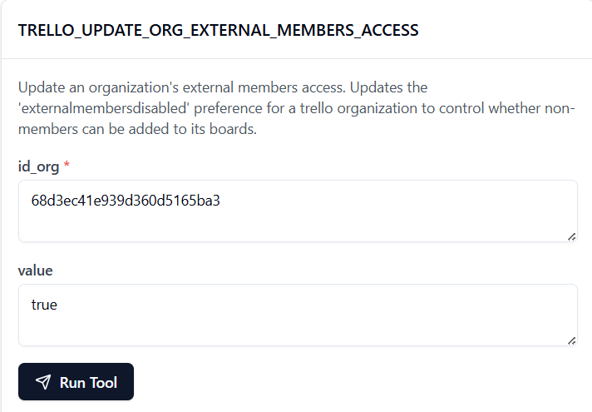

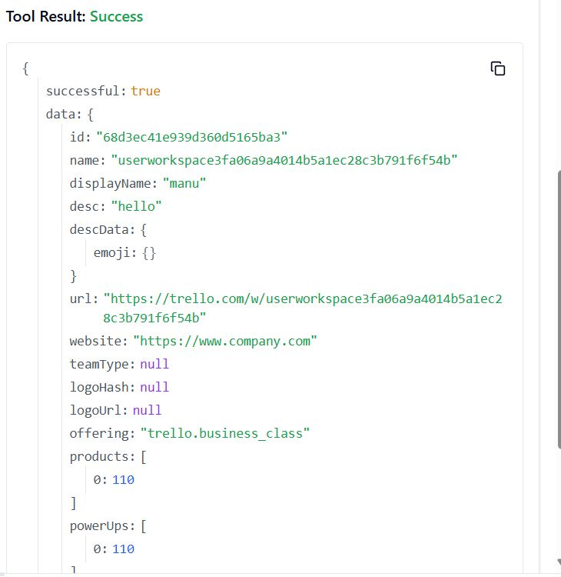

**247. TRELLO_UPDATE_WEBHOOKS_BY_ID_WEBHOOK**

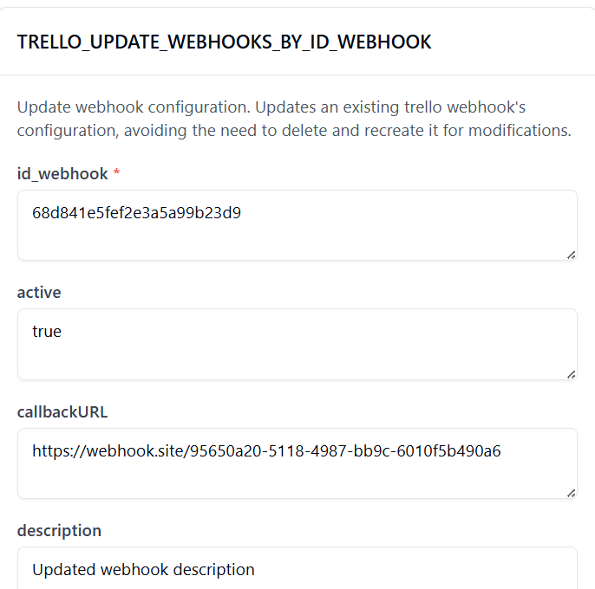

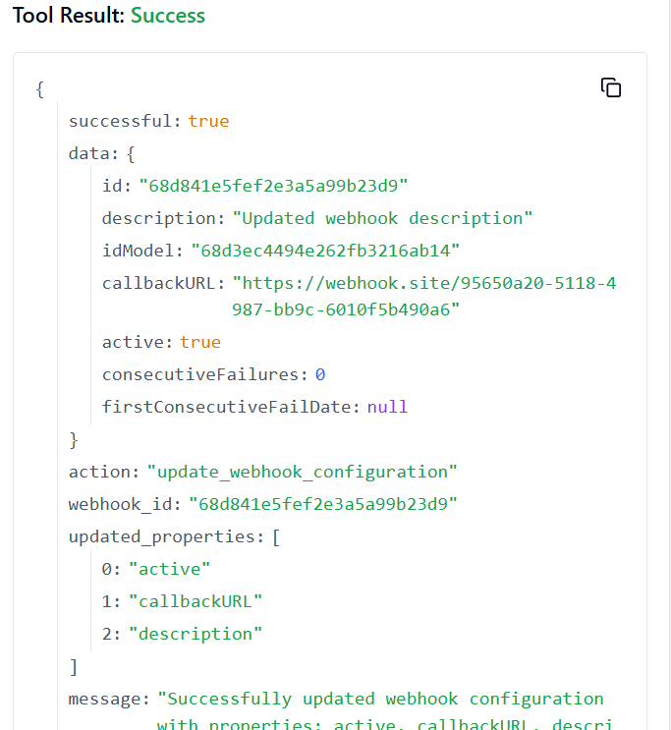

**248. TRELLO_UPDATE_WEBHOOKS_CALLBACK_URLBY_ID_WEBHOOK**

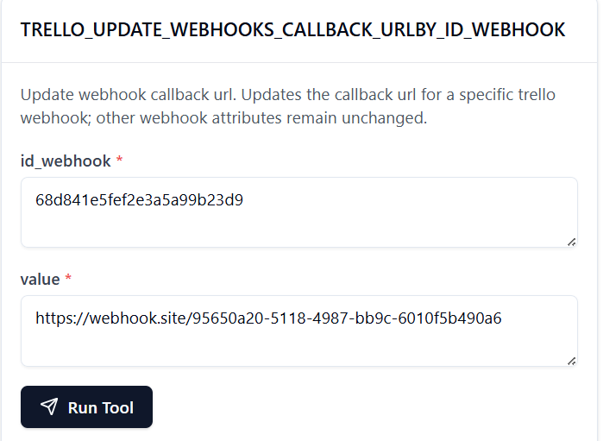

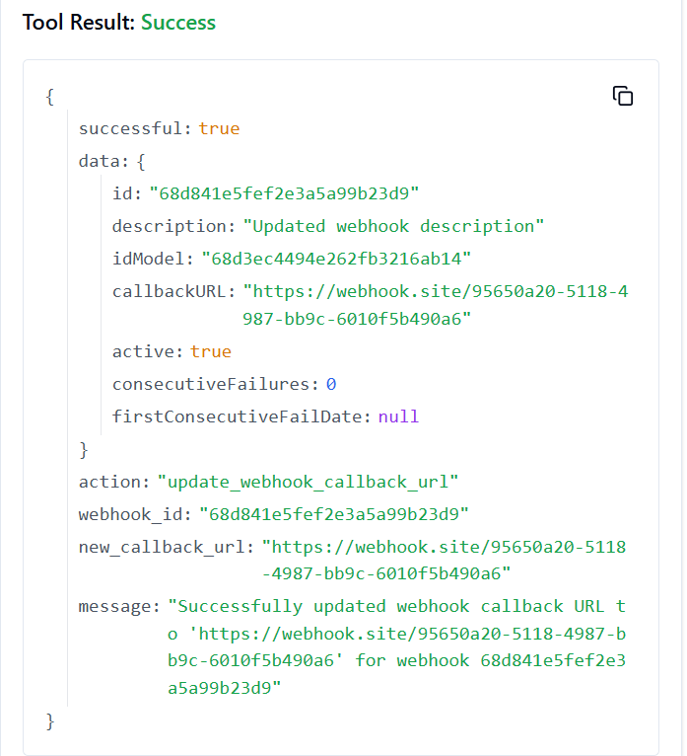

**249. TRELLO_UPDATE_WEBHOOKS_DESCRIPTION_BY_ID_WEBHOOK**

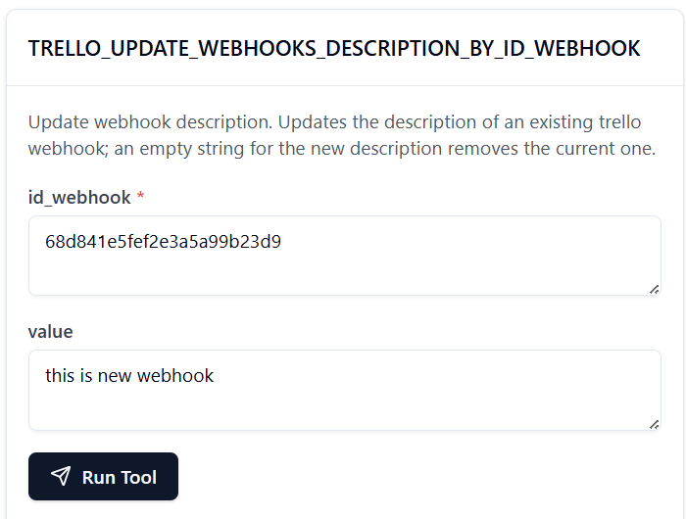

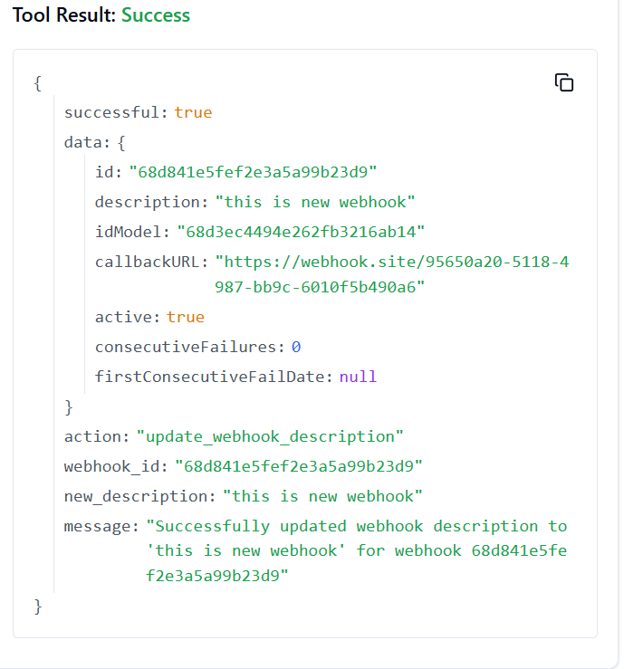

**250. TRELLO_UPDATE_WEBHOOKS_ID_MODEL_BY_ID_WEBHOOK**

